**The Greasy Rag**

**June, 2023**

**The monthly newsletter of the West Georgia Region of AACA**

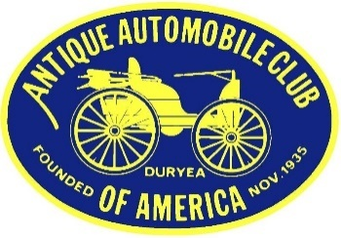

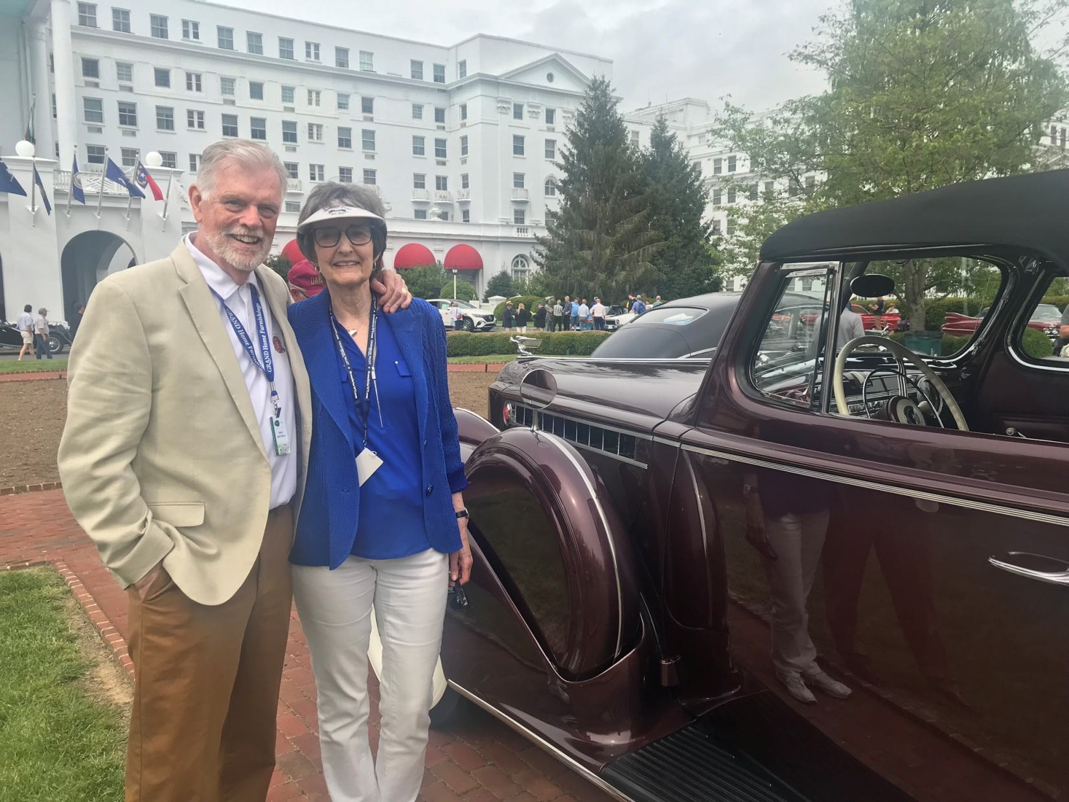

Club members Mike and Gwyneth Shotwell with their 1940 Packard convertible coupe at this year’s Greenbrier Concours d'Elegance. See story on page 7.

**President’s/Editor’s Message Glenn Novak**



Debbie and I recently returned from the **BOPC car show** on Saturday, May 6th, at Piedmont Baptist Church in Marietta. The event is held each May and is open only to Buicks, Oldsmobiles, Pontiacs and Cadillacs. There were about 60 vehicles there, ranging from 1929 to 1998. Spectators welcomed and free admission. Here are a few photos from the car show.

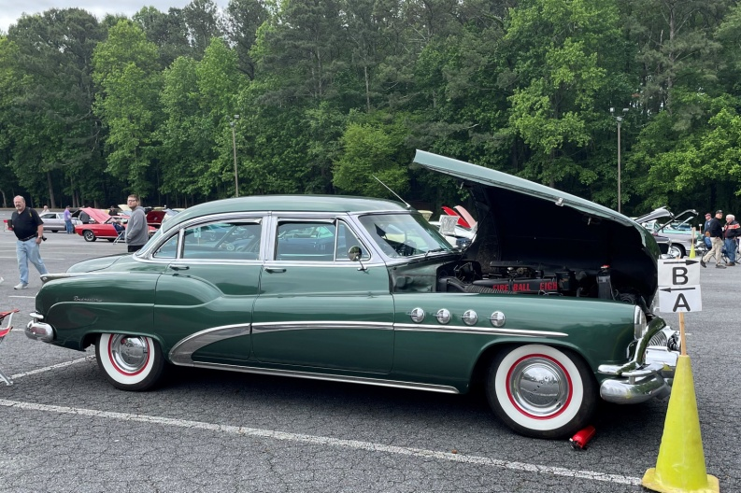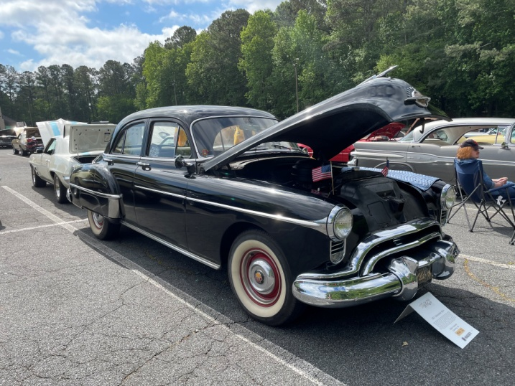

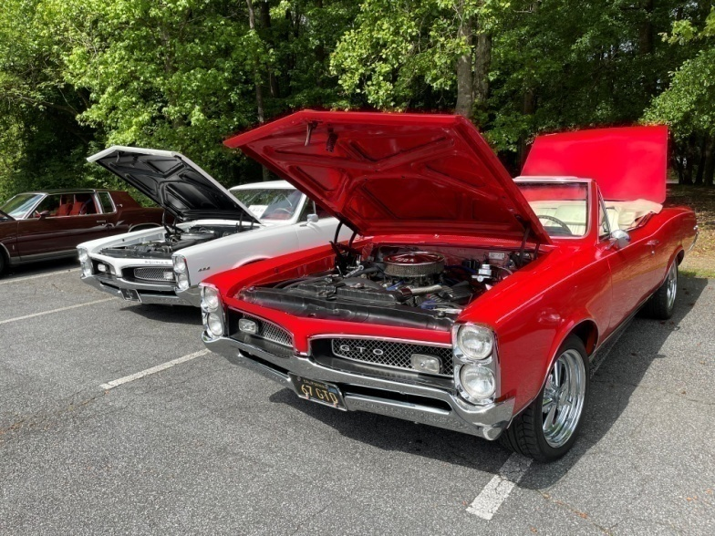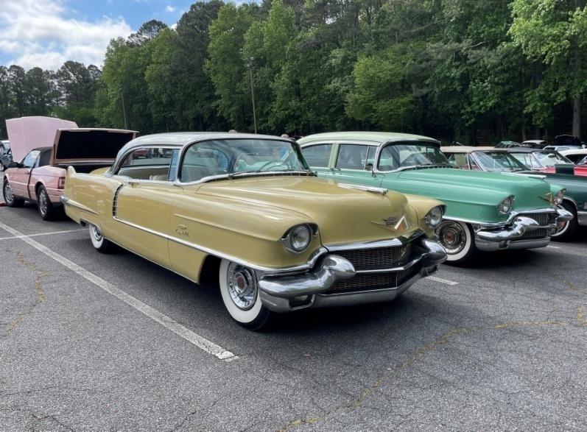

**The May 6th Savoy Museum car show** was rescheduled to the 13th due to a less than perfect weather forecast. The event was full with 250 vehicles present. Below are some photos from this inaugural event. The Fall show will be on November 11, 2023.

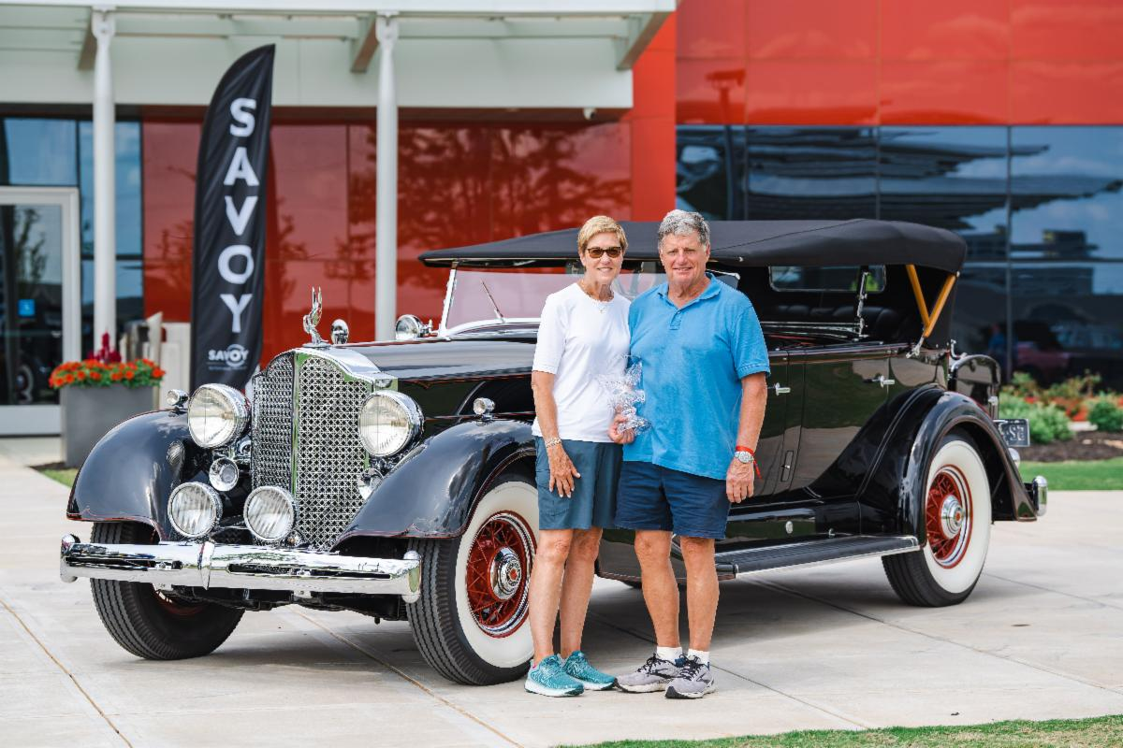

1934 Packard 1104 Super Eight Dual Cowl Phaeton won Best of Show (Savoy Choice)

Owners: Millard and Sue Choate

Photo from The Membership Minute

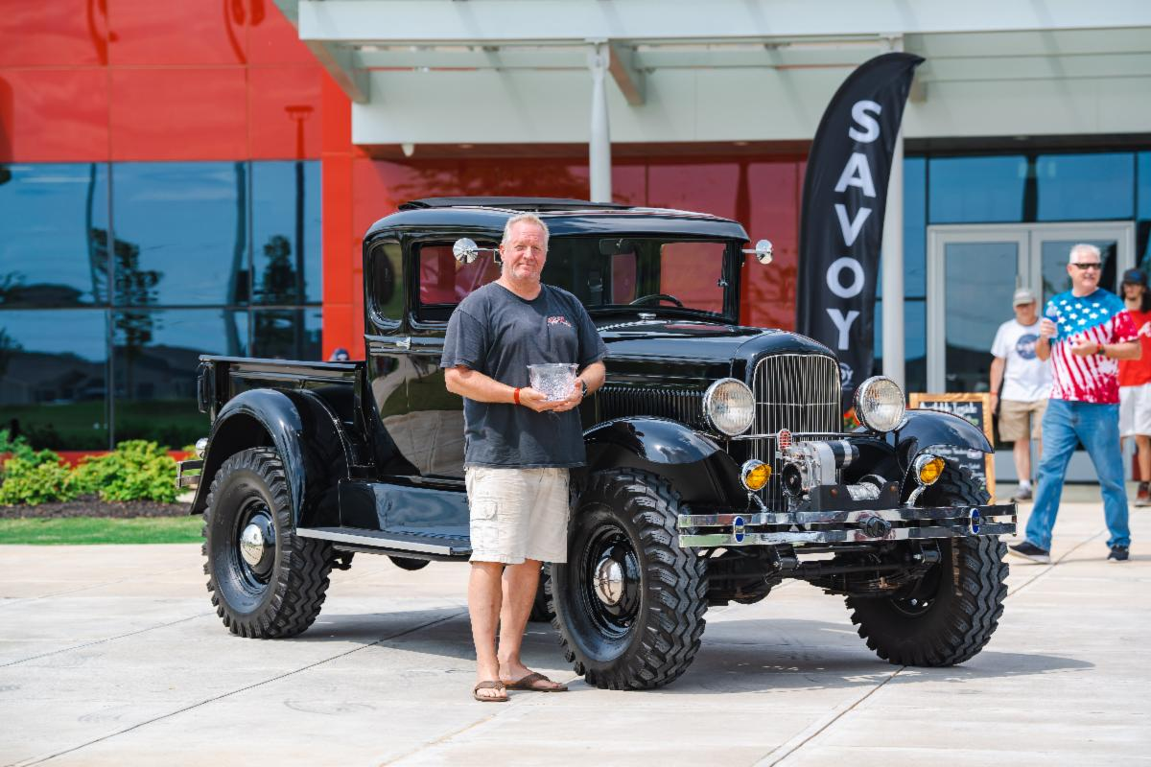

1930 Ford custom-built extended cab 4x4 (Best of Show, People’s Choice)

Owner: David Harrup

Photo from The Membership Minute

Here is a link to a YouTube video from the Savoy itself:

https://www.youtube.com/watch?v=G_v0SF2W0yg

The following photos were taken and submitted by **Bill Hearnburg**, who attended the event. We are grateful to Bill as this show will go down in history as the Inaugural Car Show at Savoy Museum, the first, we hope, of many more. Check your email and the Savoy website to learn more about the November 11th show as those details become finalized and registration deadlines are announced. It may be nice to finally have a local and large show during the cooler month of November. Their website once again is [www.savoymuseum.org](http://www.savoymuseum.org)

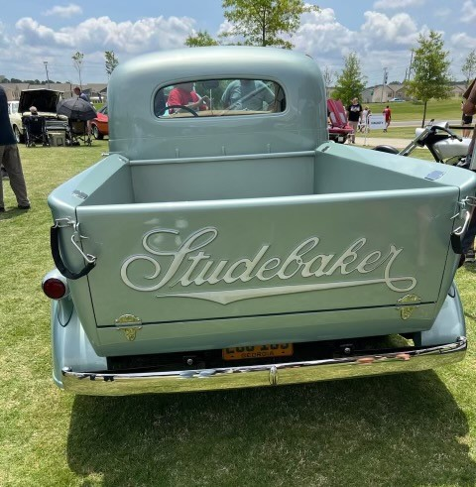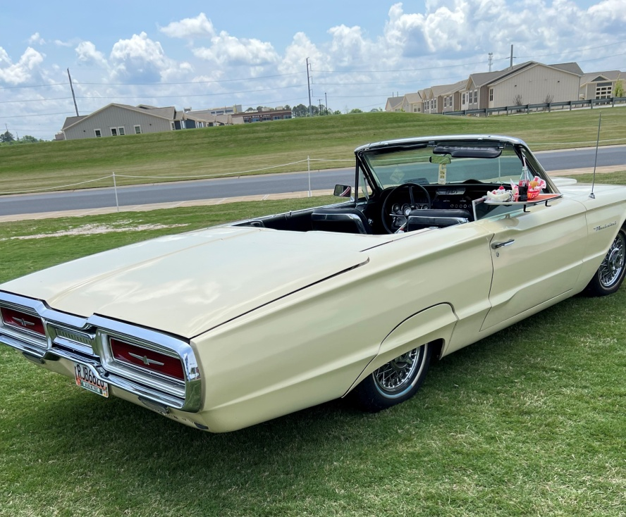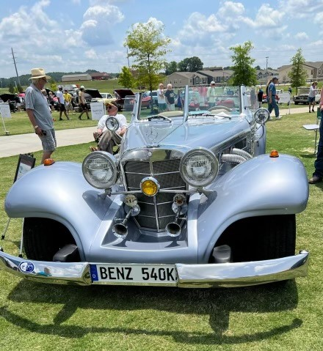

**1936 Mercedes Benz 540K Spezial Roadster, recreation of Hermann Goering car**

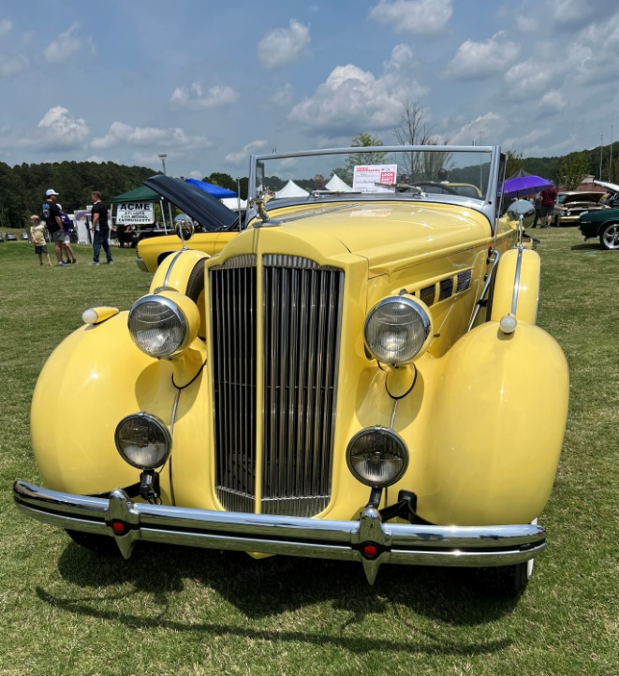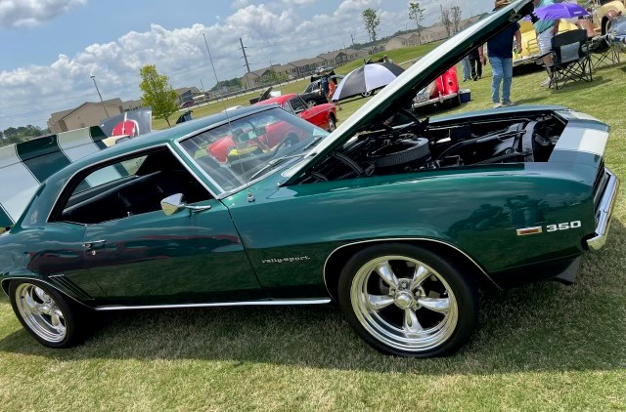

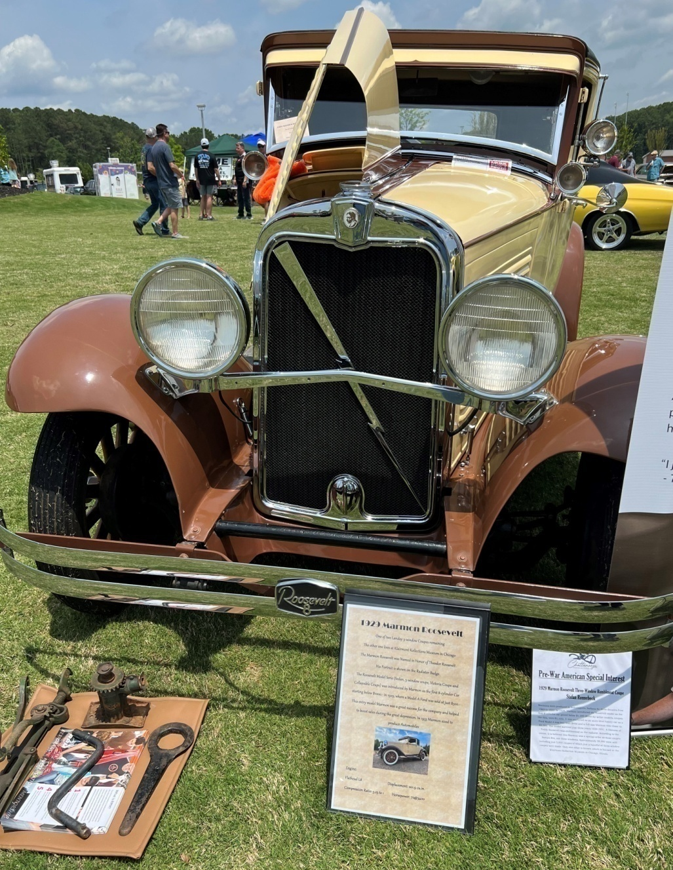

**1929 Marmon Roosevelt Landay Three-Window Coupe, one of two remaining**

**Shotwell’s Packard at the Greenbrier Concours d’Elegance**

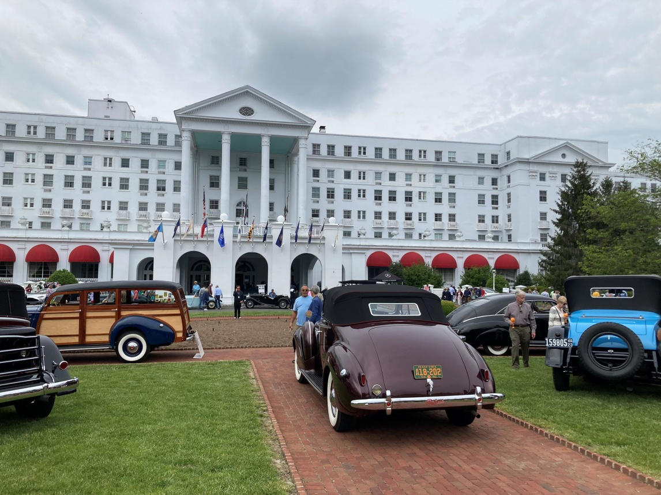

Every Spring, the famous Greenbrier Hotel in White Sulphur Springs, WV, hosts a Concours d’Elegance. The event this year was May 5-7 and the featured marque was Packard. Our West Georgia Region AACA members, Mike and Gwyneth Shotwell, had the pleasure of receiving and accepting an invitation to bring their 1940 Packard 120 convertible coupe to this event. Readers of this newsletter will recall that their fully restored car is a recent AACA Grand National winner. Their burgundy Packard is seen in the photo above on the show field facing the front of this magnificent hotel.

The photo below is a reverse-angle view of a portion of the Packard area of the show field. The event was an invitation-only Concours but was open to hotel guests and the general public as spectators.

Stay tuned for more details. The Shotwells might be interested in doing a slide show Powerpoint presentation at one of our future club meetings.

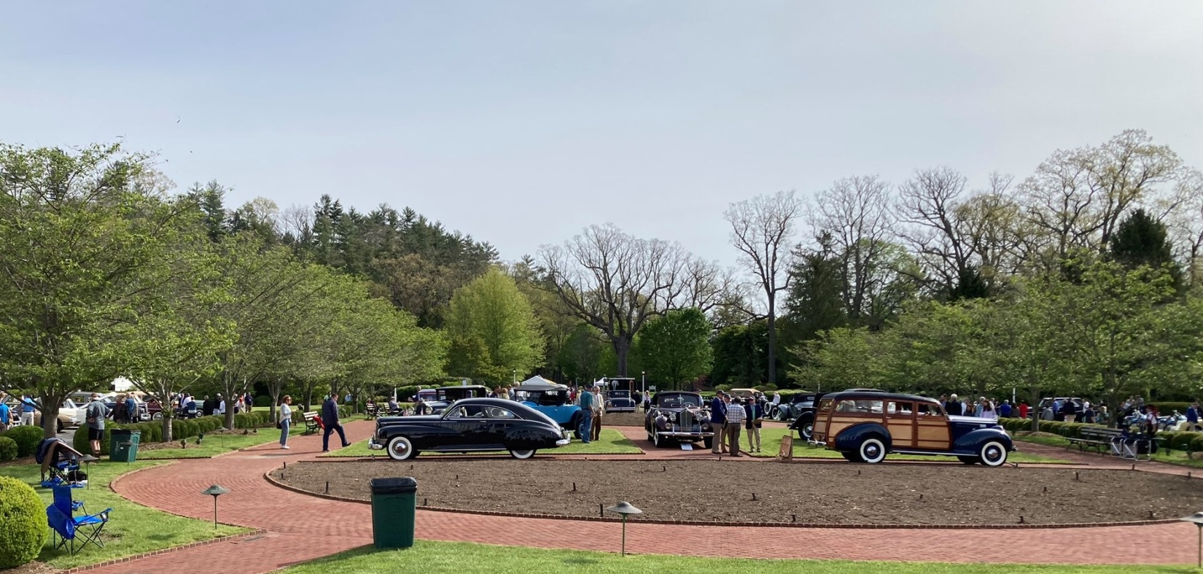

Greenbrier Concours on the morning of show day

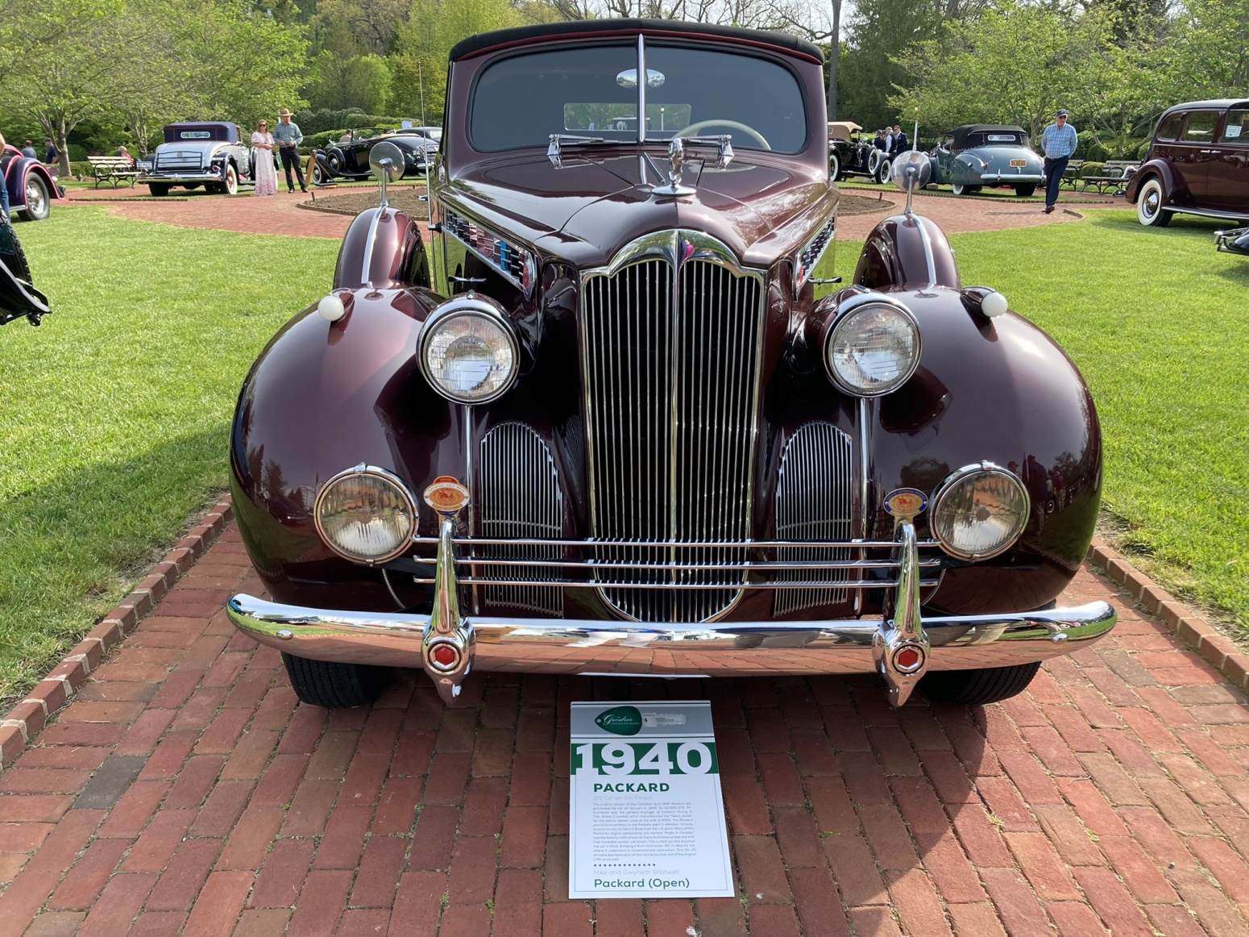

**Greenbrier photos courtesy of the Shotwells**



**Savoy Museum features Porsches**

The Savoy Museum will have a variety of Porsches on exhibit through July 30. If you like these wonderful cars, be sure to get up there before it ends.

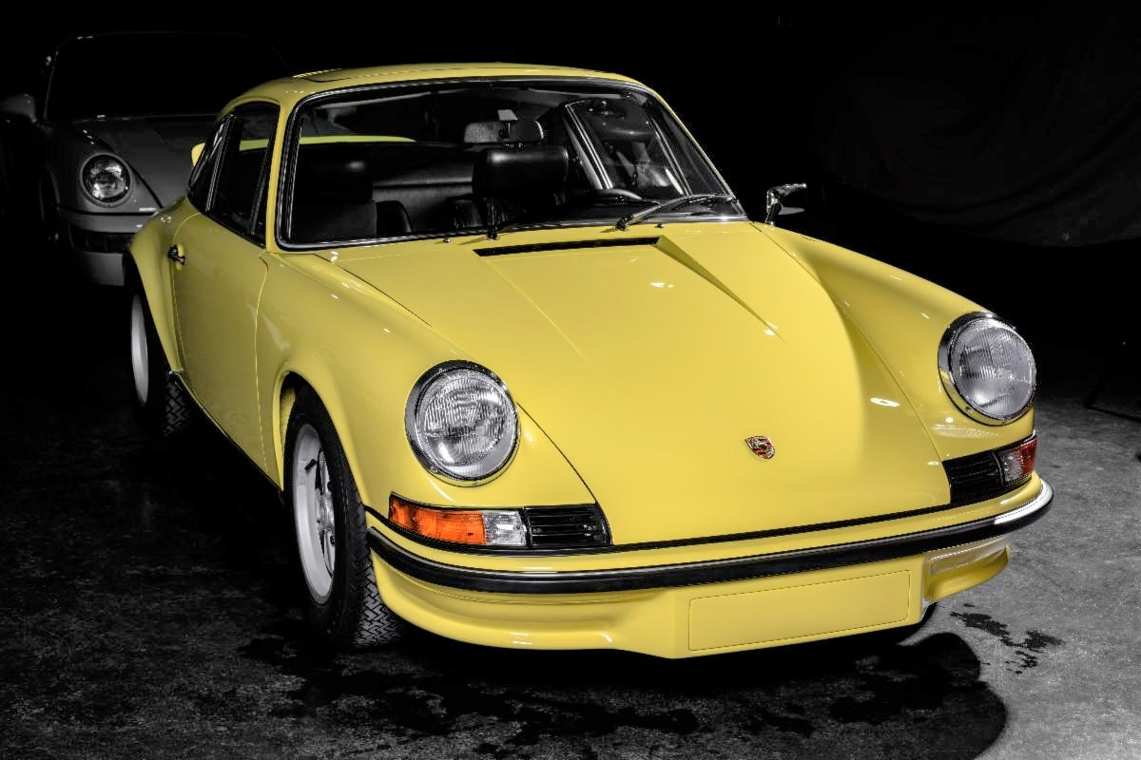

**Two photos from recent Bowdon Cruise-In**

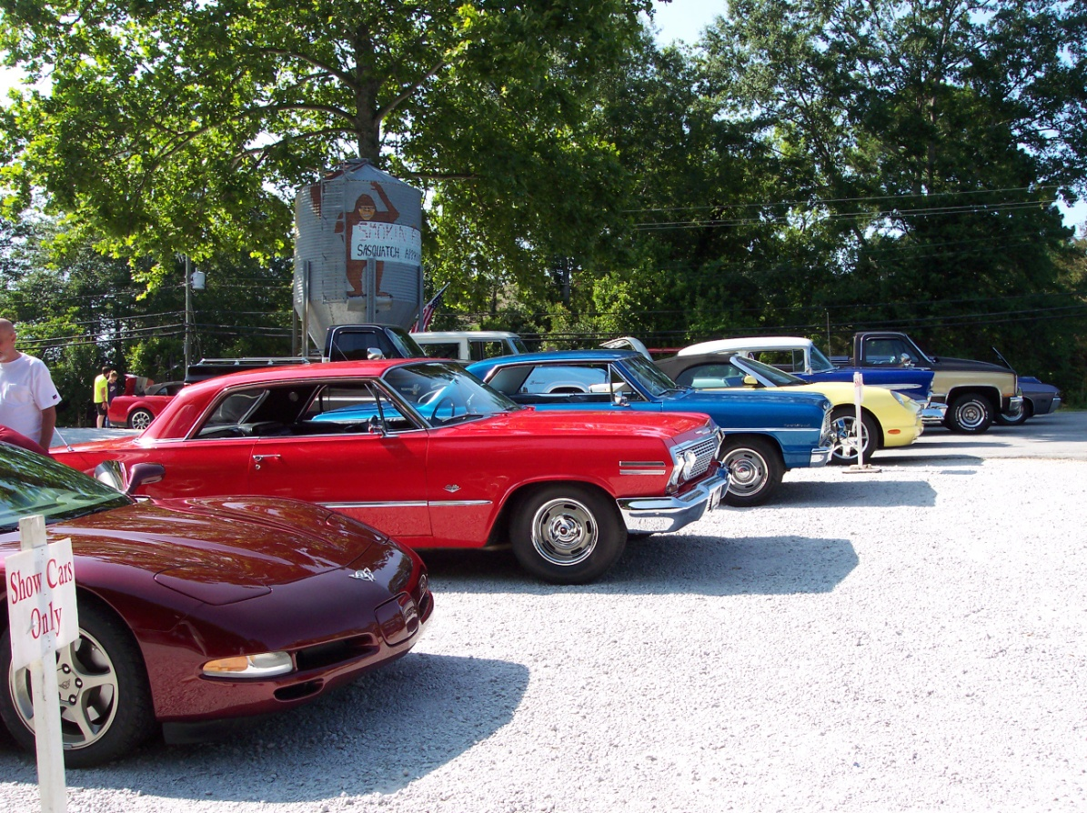

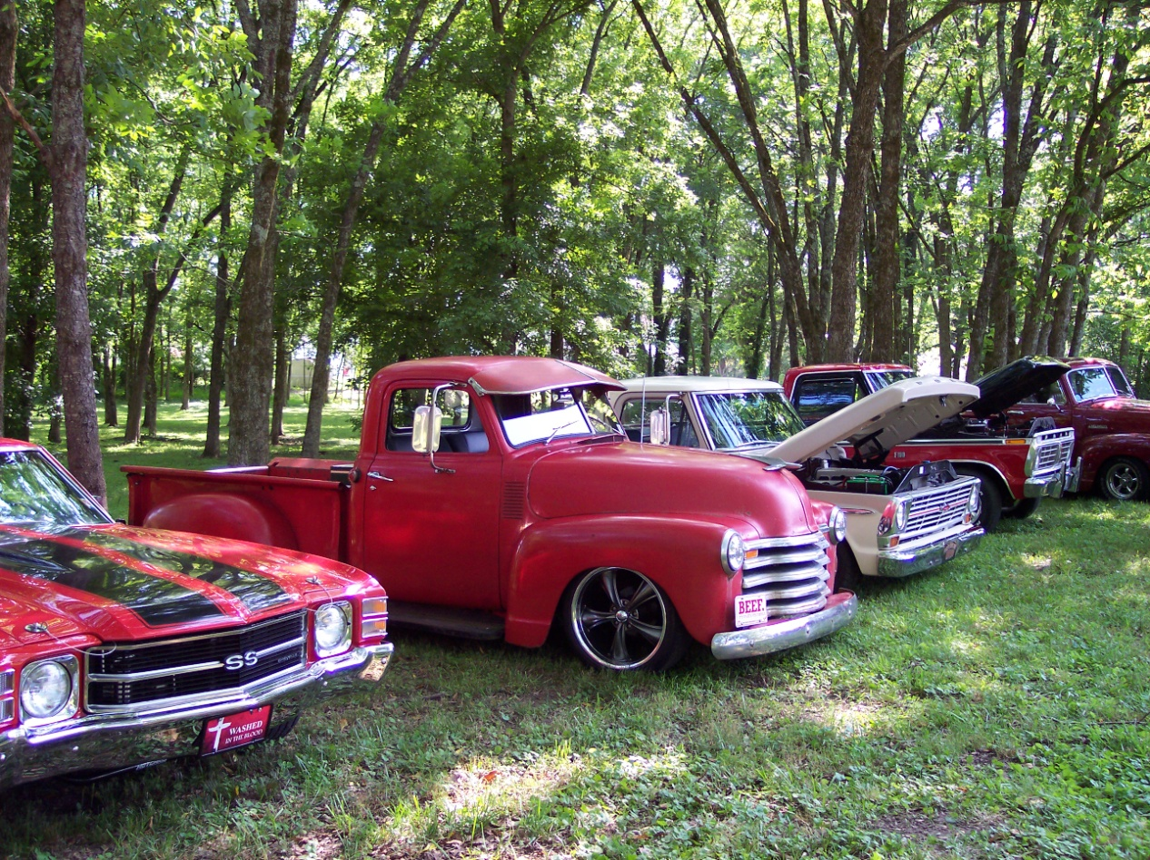

Bowdon Cruise-In at the Smokin’ Pig on May 27th.

Domain of the Ford and the Chevrolet, not the Duesy or the Delahaye

**Upcoming Events**

**June 3**: 10 am until 3 pm, annual car show at Streetside Classics, 213 Thornton Road in Lithia Springs, more details on their Facebook page, arrive early.

**June 10**: The Golden City Cruisers’ next planned outing is a visit to the garage of John and Mary Thornton, scheduled for June 10th, and our club is invited. Here are the details if you are interested in coming:

The caravan will assemble at the Citgo Convenience Store at the intersection of Highway 61 and Highway 166, an area commonly called “The Triangle”. We will depart from this area at 8:30 am and caravan to the garage of John and Mary Thornton. Rick Horne will lead the caravan.

When you are through visiting John’s Garage, you may leave when you are ready. We are not planning a group dinner afterwards.

Because John and Mary are making plans for our visit, they need a head count. If you plan to participate in this outing, please confirm as soon as possible and let Billy Glover know how many in your party. His phone number is 678-713-1265.

**June 13:** Our WGRAACA car club meeting is on **TUESDAY** at 6:30 pm at American Pie in Carrollton with a slide show by Glenn after our dinner and a brief meeting, plus a special comedy skit performed by two of our members. Please try to attend.

**June 17:** GCC cruise-in at the Villa Rica Amp from 4-8 pm

**June 24:** Bowdon cruise at the Smokin’ Pig from 4-8 pm

**June 26 - July 1**: POCI National Meet is in Murfreesboro, TN. Drive north about 224 miles and see some of the best Pontiacs and Oaklands in the nation. POCI stands for Pontiac Oakland Club International. It is a yearly judged show and you won’t find one any closer any time soon. You do not need to be a member to attend as a spectator. The host hotel is Embassy Suites, 1200 Conference Center Blvd, Murfreesboro, TN 37129 and the event website is <https://secure.poci.org/POCI_Featured_News.cfm?Tp=N&PID=45>

**July 6-8: AACA** Central Spring Nationals in Auburn, IN. (actually Waterloo). Check magazine and AACA website for details as registration is now available. See flyer below:

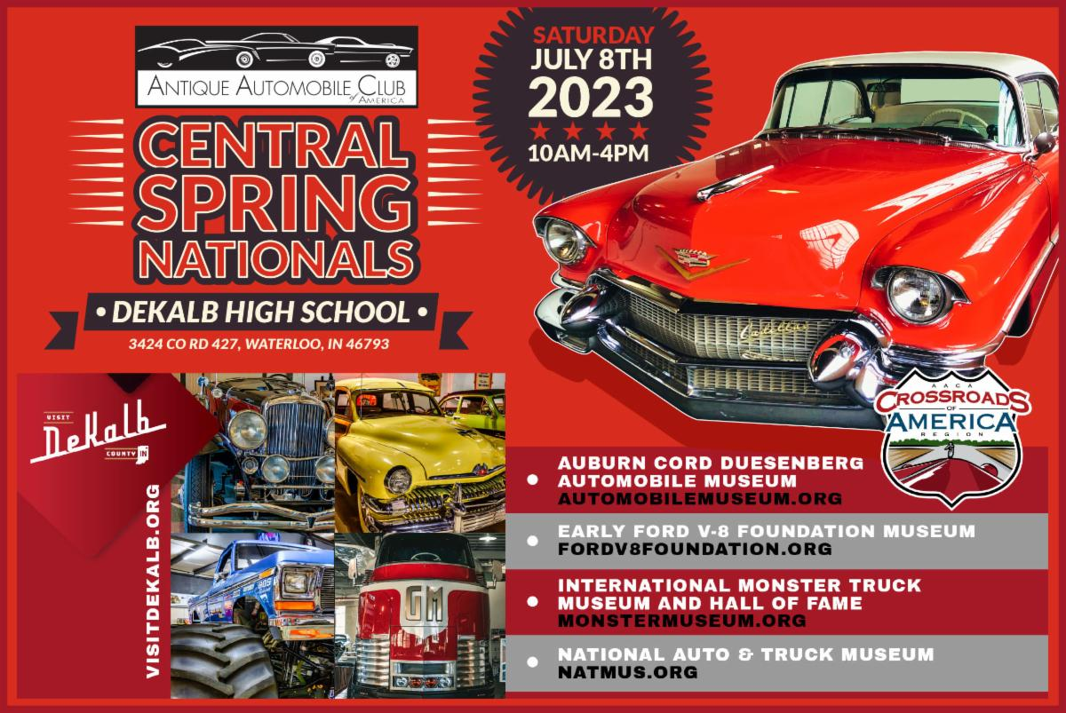

**August 16-19: Vintage Thunderbird Club International Southeast Region is having its annual car show at the Savoy in Cartersville. For details, see the link below:**

<https://www.ctci.org/vtci-international-2023-convention-august-16th-19th-2023/>

**Oct. 22-27**: **77th Revival AAA Glidden Tour** and the hub is in Thomasville, Georgia. Yes, you read this right. This famous tour is hosted in even years by AACA and in odd years by VMCCA. This is advance notice to our members who have always wanted to drive their pre-War car or truck on the Glidden. Distance from Carrollton is only 232 miles. You will never find one closer. Flyers should be available in the spring. I know we have current members with very drivable cars which qualify. Drive there or trailer.

**October 24-29:** Classic Thunderbird Club International Southeast Regional Convention, The Villages, Florida. For information, go to

[www.ctci.org](http://www.ctci.org) and click on 2023 Convention tab. After the Glidden, cruise down into Florida for the final two days of this special car show event, featuring T-Birds from all the decades.

**November 3-5**: Hilton Head Island Concours d’Elegance. The website is <https://www.hhiconcours.com/>

**November 11**: Fall car show at Savoy Museum. Watch for details in your email, in *The Greasy Rag*, on our club website, and in the *Membership Minute*.

**Photos**

If any members would like to have a picture of their vehicles featured at the top of page one of our newsletters, just email the photo to me and I would be happy to use it. A short article in MS Word is also welcome but not necessary. Just send it as a JPEG file in an email attachment to [fifteezfan@hotmail.com](mailto:fifteezfan@hotmail.com).

**Reminder**: Please let us know if your email address has changed so we can make sure you will receive this monthly newsletter and any email messages from fellow members.



Our website:

www.WestGeorgiaAaca.org