**The Greasy Rag**

**May, 2023**

**The monthly newsletter of the West Georgia Region of AACA**

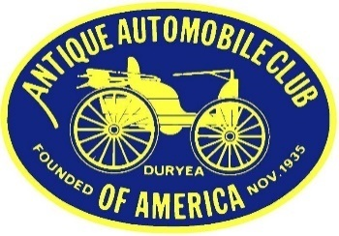

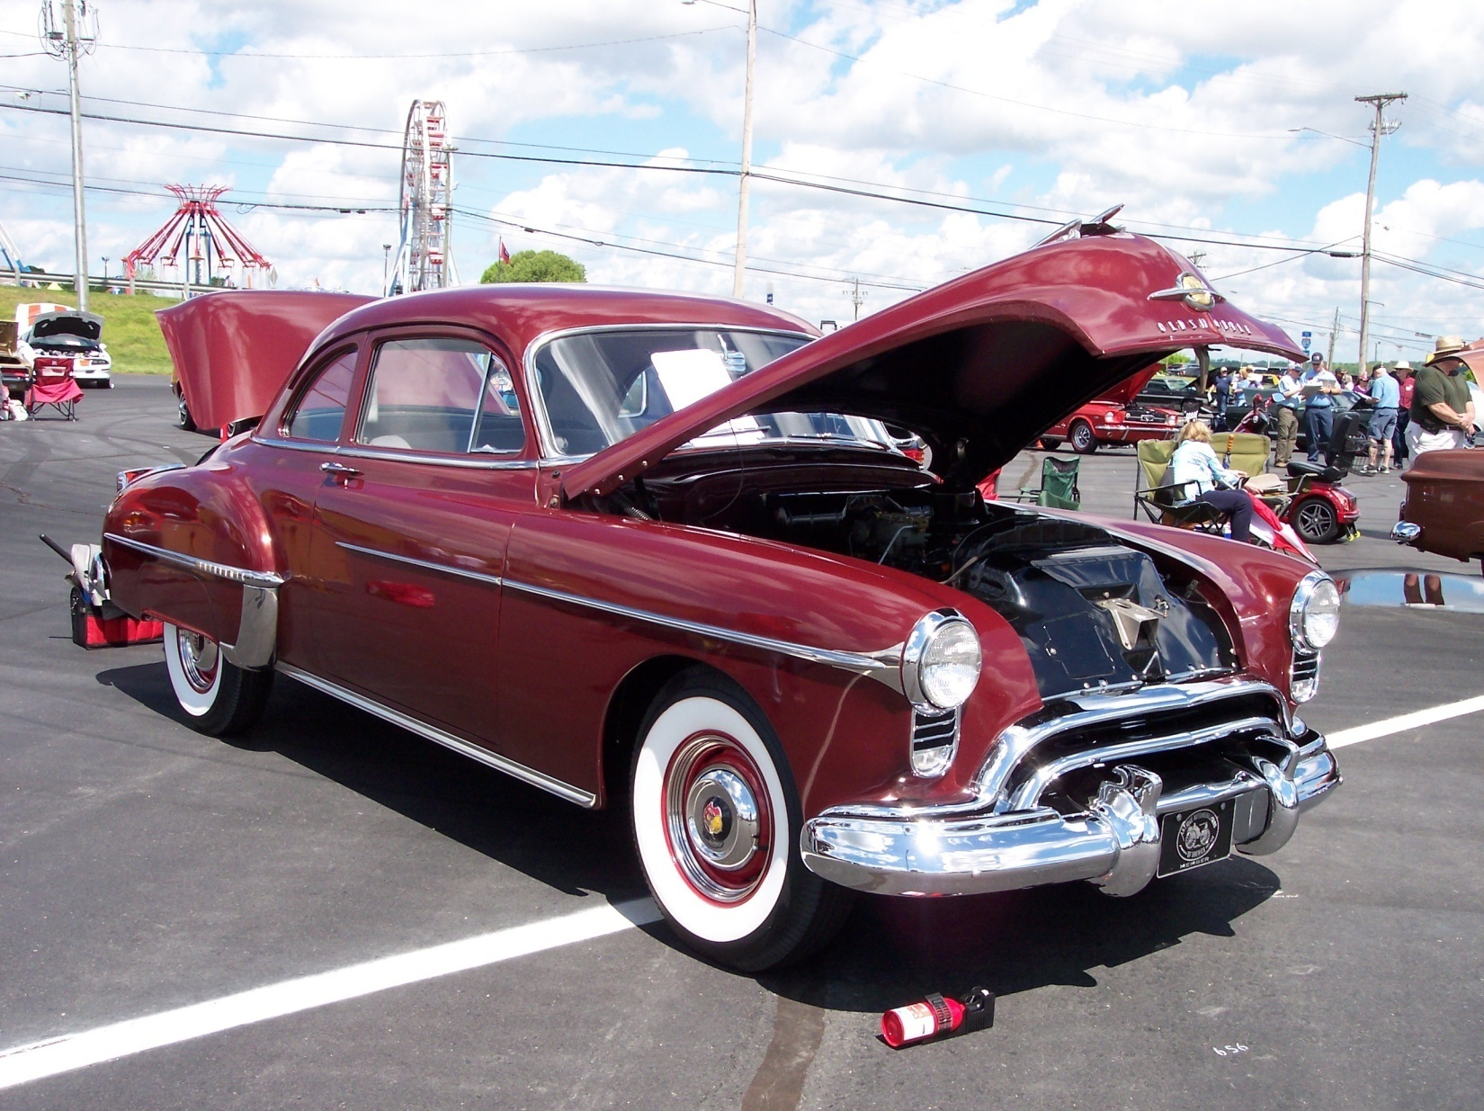

1950 Oldsmobile Club Coupe at 2023 Spring AACA Meet in Charlotte, NC

**President’s/Editor’s Message Glenn Novak**



**2023 Southeastern Spring National AACA Meet in Charlotte**

Debbie and I recently returned from this judged car show in Charlotte held on Saturday, April 15th at the Motor Speedway, as always. There were many beautiful vehicles present this year and the weather was perfect, a far cry from the frigid temperatures of last year. Our 1998 Buick Park Avenue received its HPOF certification in its first year of eligibility, and the public and evaluators offered many fine compliments. A few photos of the event follow and our members will see many more at our June 13th club meeting at American Pie.

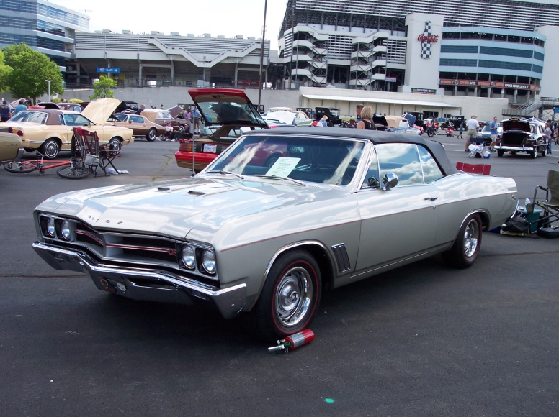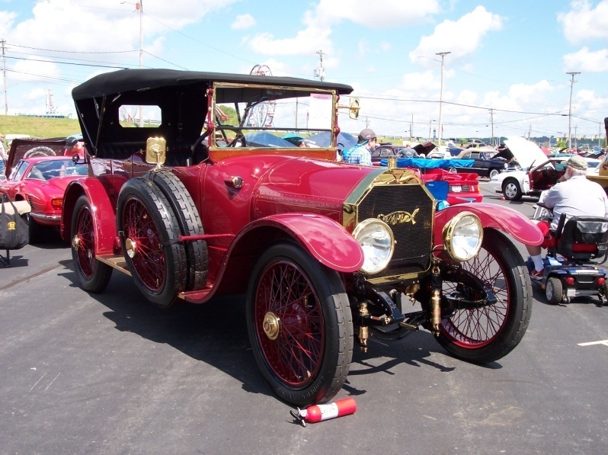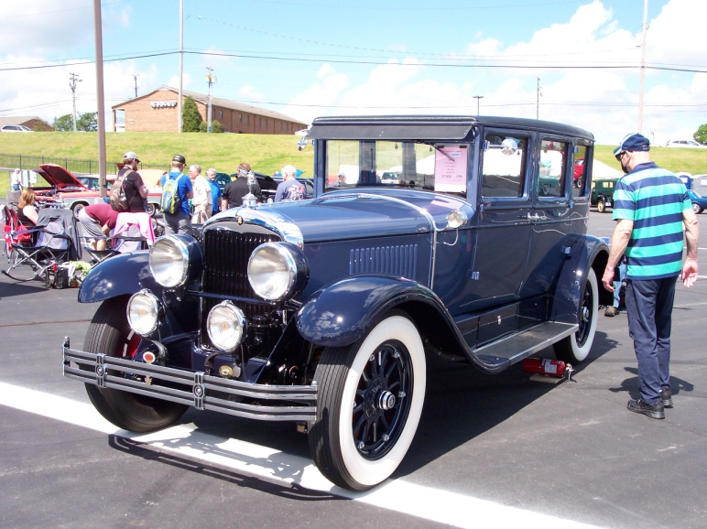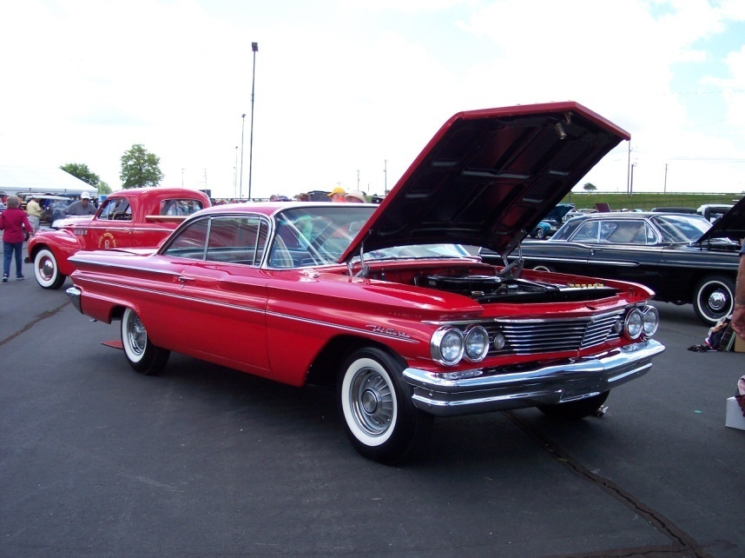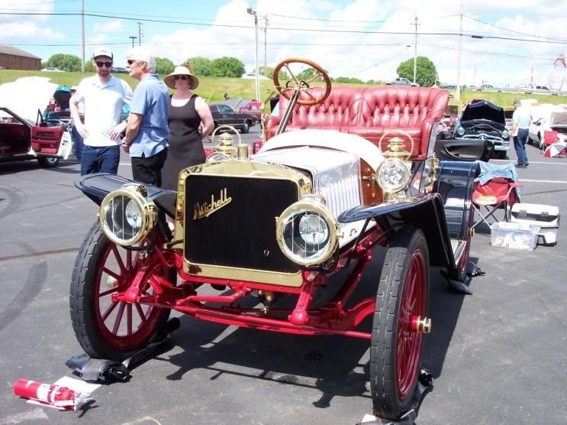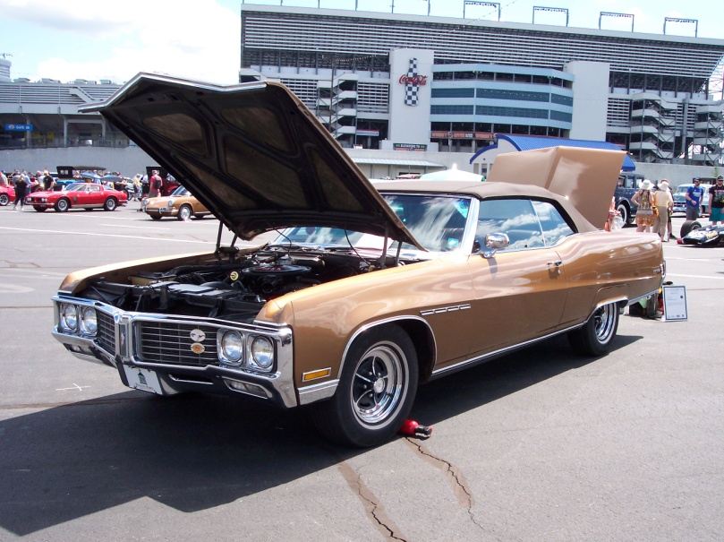

**We will meet on June 13th**

We will have a regular meeting on **Tuesday**, June 13th, at American Pie in Carrollton at 6:30 pm, with special entertainment provided by members and a slide show program after dinner. Bring some ideas for future events for the rest of this year. Meet in the Party Room as usual.

**Savoy car show photos wanted**

If you attend the May 6th car show at the Savoy Museum, please take a few photos of cars you like and send the photos to me by email. I cannot attend the event but would like to show a few photos at our June 13th car club meeting.

**Caravan to the Savoy for May 6th car show**

|  |  |  |  |
| --- | --- | --- | --- |
| *The Connection* Car Show, on the Show grounds, Savoy Museum, Cartersville. https://savoymuseum.org/event/the-connection-car-show/ Rain date is May 13th. | | |  |
|  |  |
|  |

|  |  |  |
| --- | --- | --- |
| |  |  | | --- | --- | | |  | | --- | | https://mail.google.com/mail/u/0/images/cleardot.gif | |   If you wish to drive up in a caravan with members of GCC, please contact Dale at 770-868-7119 for details on where and when to meet up. |



**Meeting on TUESDAY, June 13**

We will have a regular meeting on Tuesday, June 13th, at American Pie in Carrollton at 6:30 pm, with a program after dinner. Bring some ideas for future events for the rest of this year.

**Savoy Museum features Porsches**

The Savoy Museum has a variety of Porsches on exhibit through July 30. If you like these wonderful cars, be sure to get up there before it ends.

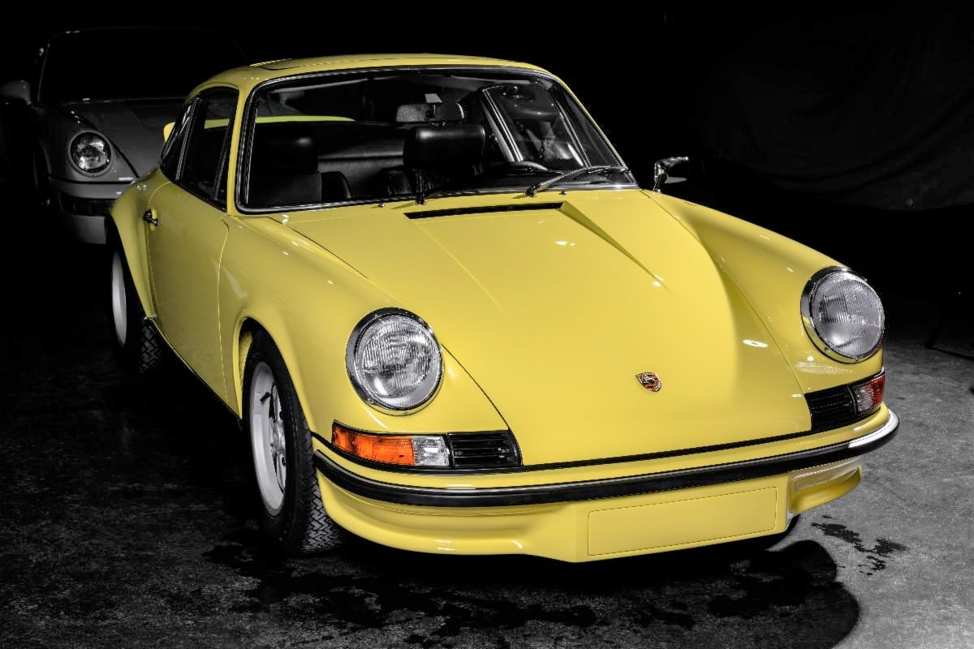

Some of our members attended the Corvair National Meet in Peachtree City, GA and the Porsche show at Shot Spot last year. These events had nothing at all to do with AACA. But, we had fun. Here are some events coming up which you might enjoy.

**May 5-7:** The 2023 Greenbrier Concours d'Elegance, ​101 Main Street West, ​White Sulphur Springs, WV 24986, website is https://www.greenbrierconcours.com/ Distance from Carrollton is 507 miles. A very high-end event.

**May 6:** *The Connection* Car Show, on the Show grounds, Savoy Museum, Cartersville. https://savoymuseum.org/event/the-connection-car-show/ Rain date is May 13th.

**May 6**: Annual Buick-Olds-Pontiac-Cadillac (BOPC) car show at Piedmont Baptist Church in Marietta, 8 am-3 pm, details at <http://dixie.buickclub.org/wp-content/uploads/2022/11/0522-2023-BOPC.pdf>

**May 7:** British Motorcar Day in Suwanee, GA. Details are at https://www.atlantabritishmotorcarday.org/

**May 20**: Ridz by the River car show in Cartersville, 10 am – 3 pm, details at <https://ridzbytheriver.com/event-info/>

**May 20:** GCC cruise-in at the Villa Rica Amp from 4-8 pm

**May 27:** Bowdon cruise at the Smokin’ Pig from 4-8 pm

**June 13**: Our car club meeting is on **TUESDAY** at 6:30 pm at American Pie in Carrollton with a slide show after our dinner and a brief meeting, plus a special comedy skit performed by two of our members. Please try to attend.

**June 26 - July 1**: POCI National Meet is in Murfreesboro, TN. Drive north about 224 miles and see some of the best Pontiacs and Oaklands in the nation. POCI stands for Pontiac Oakland Club International. It is a yearly judged show and you won’t find one any closer any time soon. You do not need to be a member to attend as a spectator. The host hotel is Embassy Suites, 1200 Conference Center Blvd, Murfreesboro, TN 37129 and the event website is <https://secure.poci.org/POCI_Featured_News.cfm?Tp=N&PID=45>

**July 6-8: AACA** Central Spring Nationals in Auburn, IN. (actually Waterloo). Check magazine and AACA website for details as registration is now available. See flyer below:

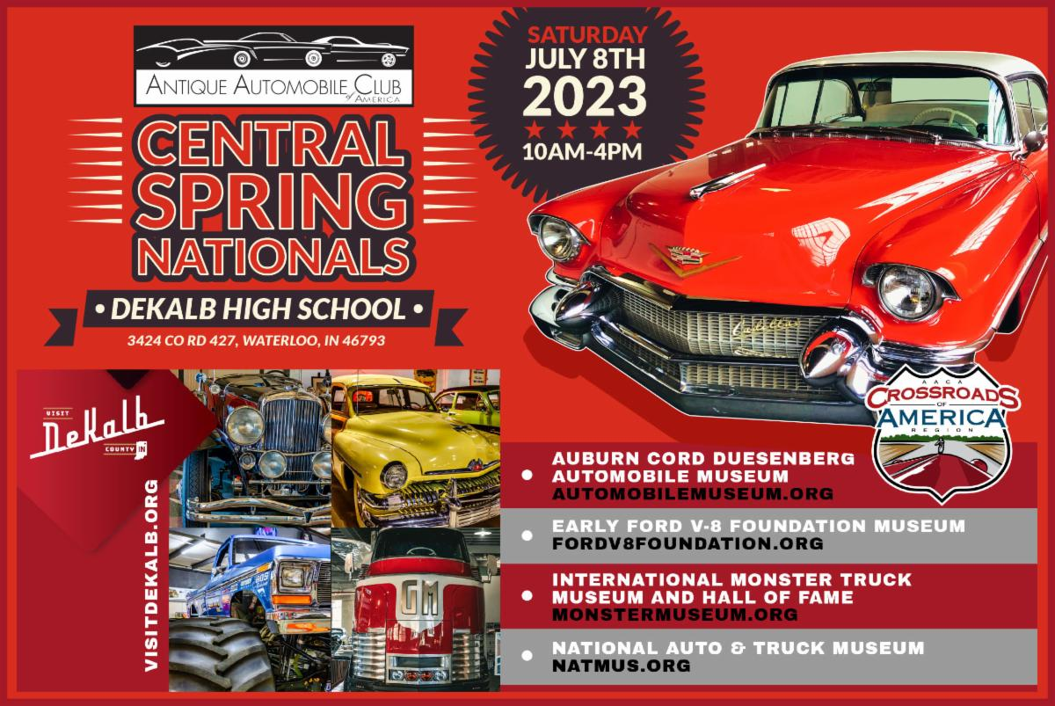

**Oct. 22-27**: **77th Revival AAA Glidden Tour** and the hub is in Thomasville, Georgia. Yes, you read this right. This famous tour is hosted in even years by AACA and in odd years by VMCCA. This is advance notice to our members who have always wanted to drive their pre-War car or truck on the Glidden. Distance from Carrollton is only 232 miles. You will never find one closer. Flyers should be available in the spring. I know we have current members with very drivable cars which qualify. Drive there or trailer.

**October 24-29:** Classic Thunderbird Club International Southeast Regional Convention, The Villages, Florida. For information, go to

[www.ctci.org](http://www.ctci.org) and click on 2023 Convention tab. After the Glidden, cruise down into Florida for the final two days of this special car show event, featuring T-Birds from all the decades.

**November 3-5**: Hilton Head Island Concours d’Elegance. The website is https://www.hhiconcours.com/

**Photos**

If any members would like to have a picture of their vehicles featured at the top of page one of our newsletters, just email the photo to me and I would be happy to use it. An article in Word, short or long, is also welcome but not necessary. Just send it as a JPEG file in an email attachment to [fifteezfan@hotmail.com](mailto:fifteezfan@hotmail.com).

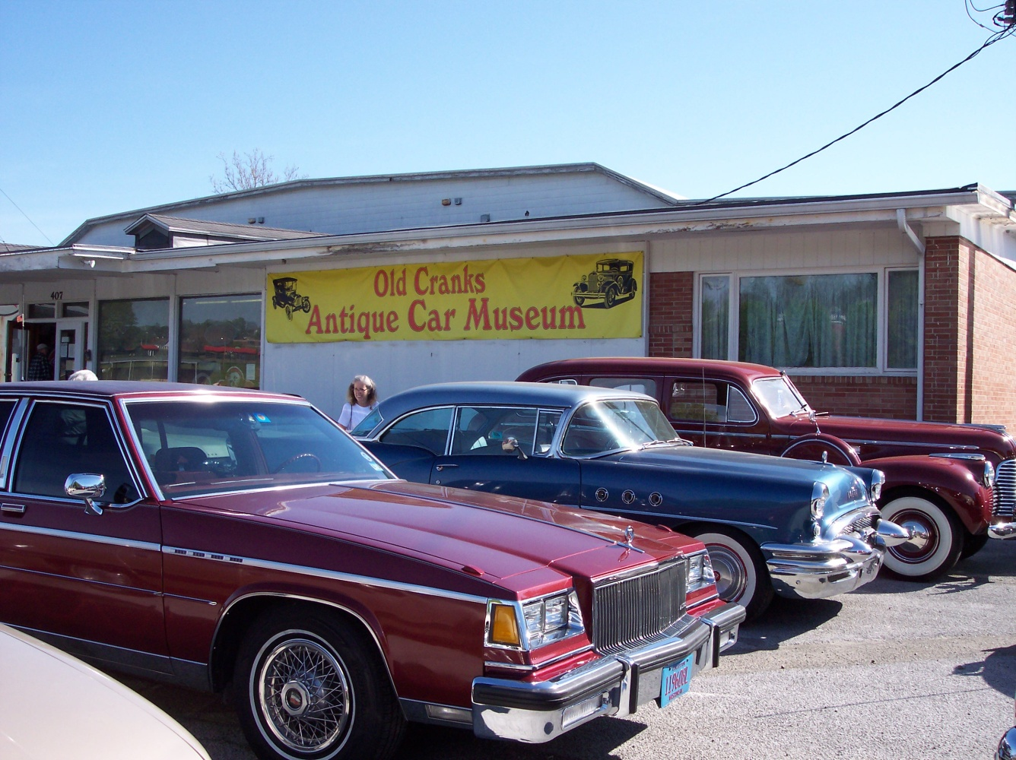

**Why are only Buicks seen outside this car museum? Find out on June 13th**



Oh! fragrant is the breath of May  
In tranquil garden closes,  
And soft yet regal is her sway  
Among the springtide roses.  
—William Hamilton Hayne, American poet (1856–1929)

**Our Club Website:** www.WestGeorgiaAACA.org



MAY 29, 2023

**Memorial Day Trivia:**

Memorial Day, originally known as Decoration Day, honored only those lost while fighting in the Civil War. Memorial Day now honors all members of the Military who gave their lives while serving in the U.S. Armed Forces.

The first national Memorial Day celebration on May 30, 1868, was held at Arlington National Cemetery with a crowd of 5,000 people decorating the graves of over 20,000 military personnel with flowers.

In 1971 Memorial Day became a federal holiday.

<https://www.history.com/topics/holidays/memorial-day-history>