**The Greasy Rag**

**April, 2023**

**The monthly newsletter of the West Georgia Region of AACA**

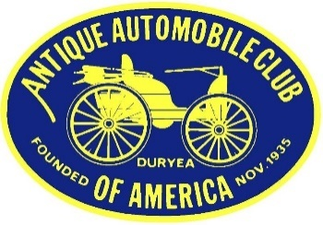

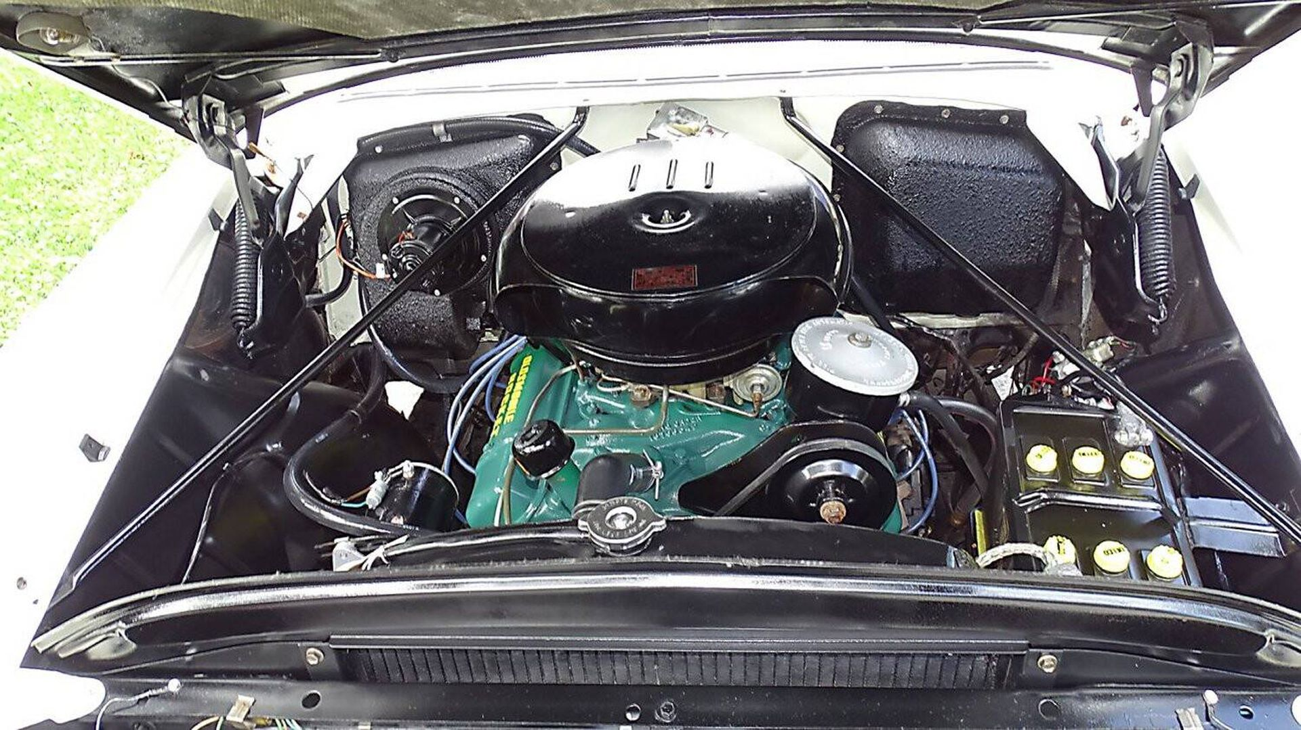

Back when the owner could see the engine, get to it, and work on it. Then take a drive, maybe get some gas, roll over the rubber bell hose, and tell the guy “Fill it up with ethyl and check the oil”

**President’s/Editor’s Message Glenn Novak**



Hope everyone is doing well and starting once again to enjoy those old hobby cars and trucks during the early spring touring and show season right around the corner. There are events coming up as soon as April 1st so take a look at the schedule below in this newsletter. I have scheduled a meeting on June 13th at American Pie in Carrollton, as some members seem to enjoy the traditional group meeting environment. The company is good and so is the food. Stay tuned, and try to attend.

**Former WGR AACA member Frank Hummel** has had his car article and photo published in the March/April issue #78 of the *Hagerty Drivers Club* magazine, page 40. His article gives some brief background and performance data on his Ignition Orange 2008 Pontiac G8 GT which he purchased in 2017. This magazine is a national publication and we congratulate Frank on this accomplishment.

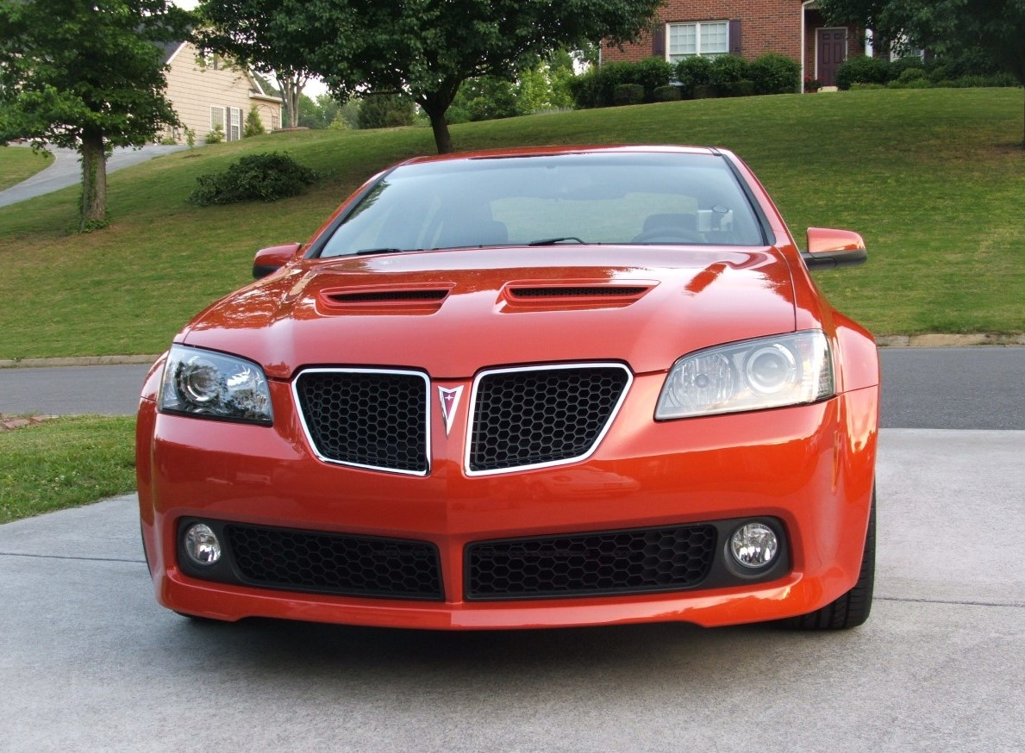

Frank Hummel’s 2008 Pontiac G8 GT, a modern sedan which can do 160-mph on 87 octane fuel. The last of the Pontiac V-8’s from a nameplate that has sadly vanished from the GM portfolio (along with Oldsmobile).

Recently **Bill and Gary** drove up to Summerville, GA to tour Vintage Corvettes and Classic Cars by Greg Wyatt. In addition to many wonderful cars, most for sale, the owner has a huge collection of signs, gas pumps, and assorted motoring memorabilia. The website is <https://vintagecorvettes.com/> Below are some photos which Bill took.

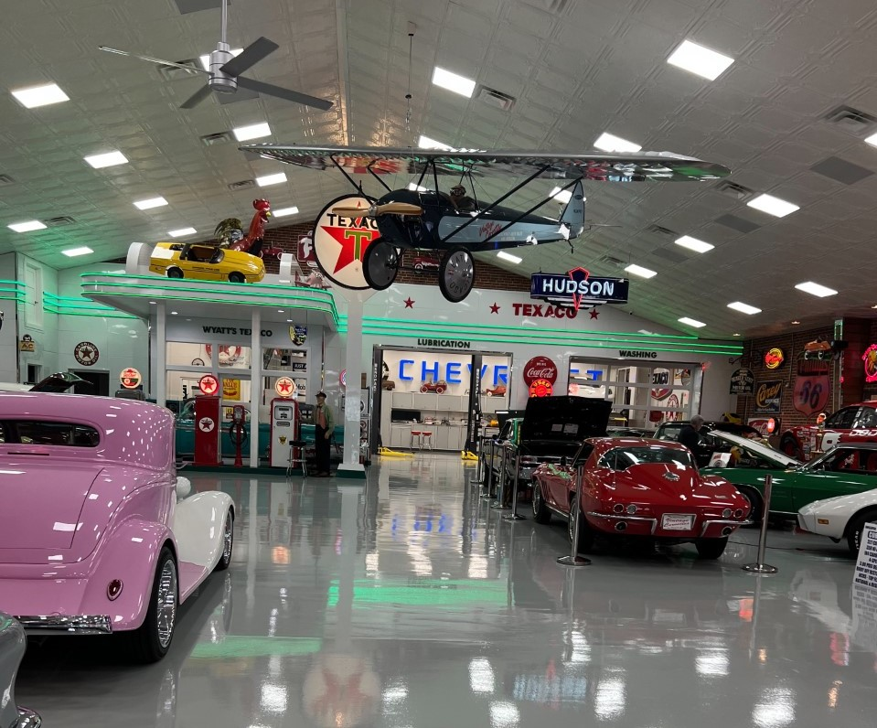

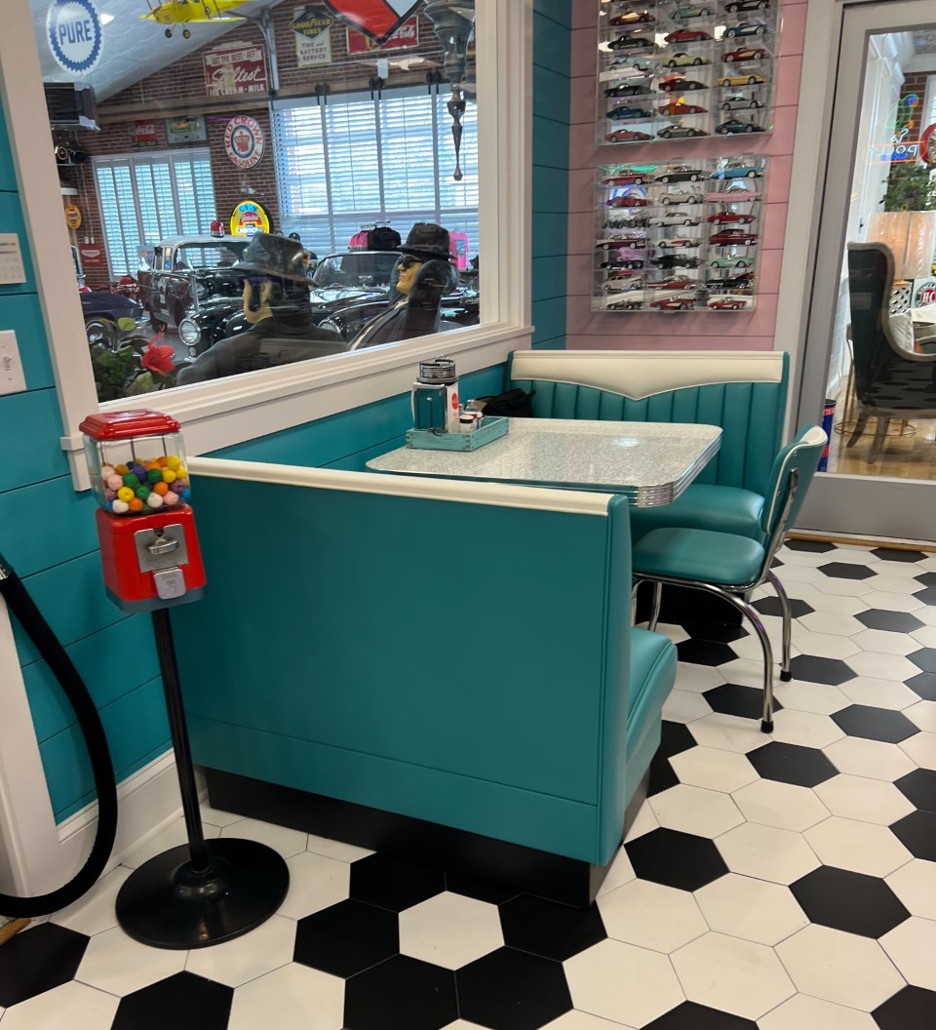

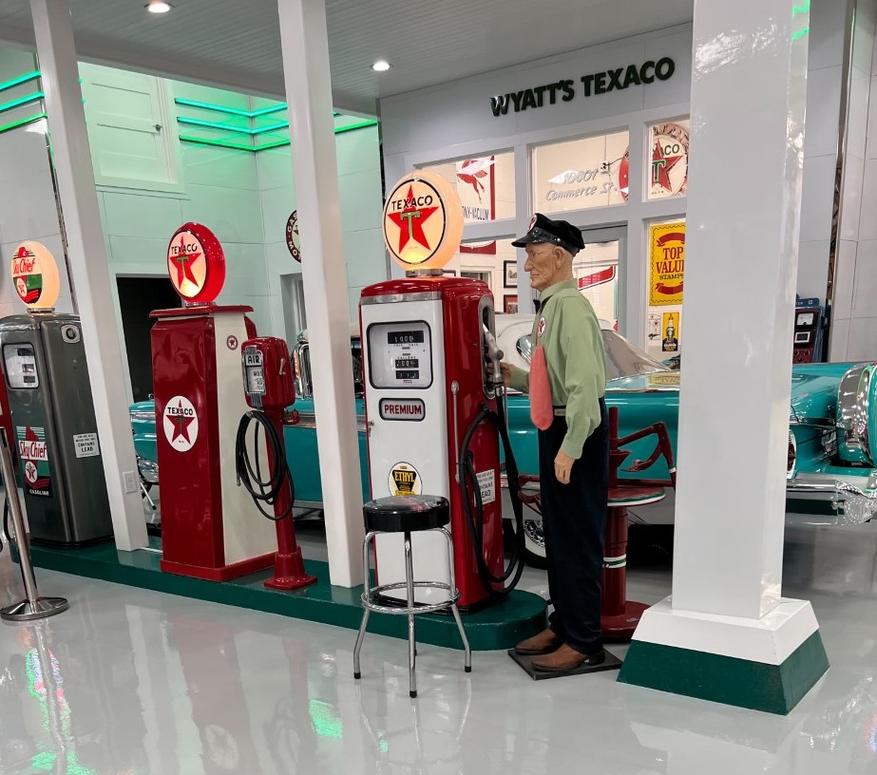



**Our next meeting**

**We will have a regular club meeting on Tuesday, June 13th at 6:30 pm at American Pie in Carrollton. Please mark your calendars now and try to save that evening for one of our infrequent business meetings, with a program to follow. (Sunset will be at 8:53 pm.)**

Here are some events coming up which you might enjoy.

**April 1**: Sargent Baptist Church annual car show. Newnan from 9-2.

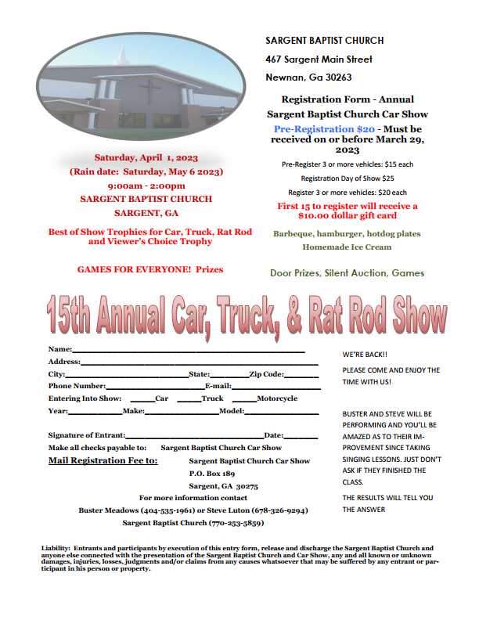

**April 13-15**: Charlotte AACA at the Motor Speedway in Concord, NC. From Carrollton, the distance is 313 miles. The flyers and registration materials are now available on the national website. <https://aaca.org/event/2023-aaca-southeastern-spring-nationals/>

**April 15:** GCC cruise-in at the Villa Rica Amp from 4-8 pm

**April 22:** Bowdon cruise at the Smokin’ Pig from 4-8 pm

**April 29:** CCAS (College and Career Academy South) car show in Carrollton . It will be at the same location as last year--the College and Career Academy South Campus, 1075 Newnan Road, Carrollton, (West Georgia Tech) this is near the turnaround on Highway 27 and the dump. Theshow is from 10:00-2:00. There will be food and trophies. CCAS automotive students are putting on the show. The registration fee is $25. Email is [steve.sumner@carrollcountyschools.com](mailto:steve.sumner@carrollcountyschools.com) for more info. The flyer is below:

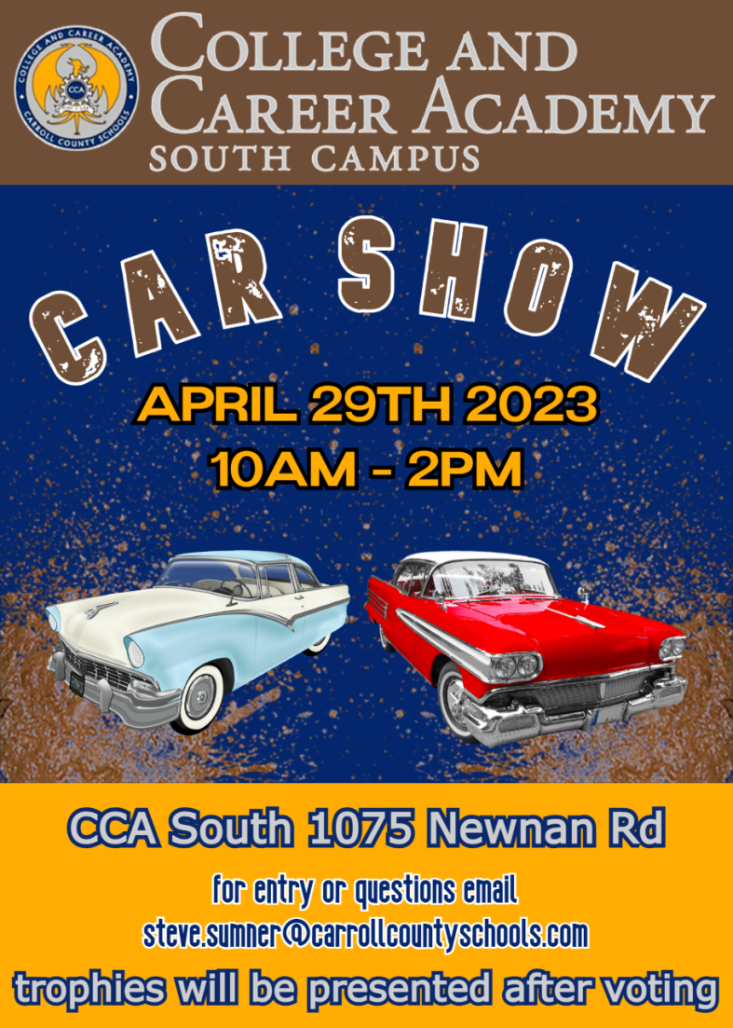

**May 6:** *The Connection* Car Show, on the Show grounds, Savoy Museum, Cartersville. https://savoymuseum.org/event/the-connection-car-show/ Rain date is May 13th.

**May 5-7:** The 2023 Greenbrier Concours d'Elegance, ​101 Main Street West, ​White Sulphur Springs, WV 24986, website is https://www.greenbrierconcours.com/ Distance from Carrollton is 507 miles. A very high-end event.

**May 6**: Annual Buick-Olds-Pontiac-Cadillac (BOPC) car show at Piedmont Baptist Church in Marietta, 8 am-3 pm, details at <http://dixie.buickclub.org/wp-content/uploads/2022/11/0522-2023-BOPC.pdf>

May 7: British Motorcar Day in Suwanee, GA. Details are at https://www.atlantabritishmotorcarday.org/

**May 20**: Ridz by the River car show in Cartersville, 10 am – 3 pm, details at <https://ridzbytheriver.com/event-info/>

**June 13**: Our car club meeting on Tuesday at 6:30 pm at American Pie in Carrollton with a slide show after our dinner and a brief meeting, plus a special comedy skit performed by two of our members. Please try to attend.

**June 26 - July 1**: POCI National Meet is in Murfreesboro, TN. Drive north about 224 miles and see some of the best Pontiacs and Oaklands in the nation. POCI stands for Pontiac Oakland Club International. It is a yearly judged show and you won’t find one any closer any time soon. You do not need to be a member to attend as a spectator. The host hotel is Embassy Suites, 1200 Conference Center Blvd, Murfreesboro, TN 37129 and the event website is <https://secure.poci.org/POCI_Featured_News.cfm?Tp=N&PID=45>

**July 6-8: AACA** Central Spring Nationals in Auburn, IN. (actually Waterloo). No details yet. Check magazine and website for details as they become available. See flyer below:

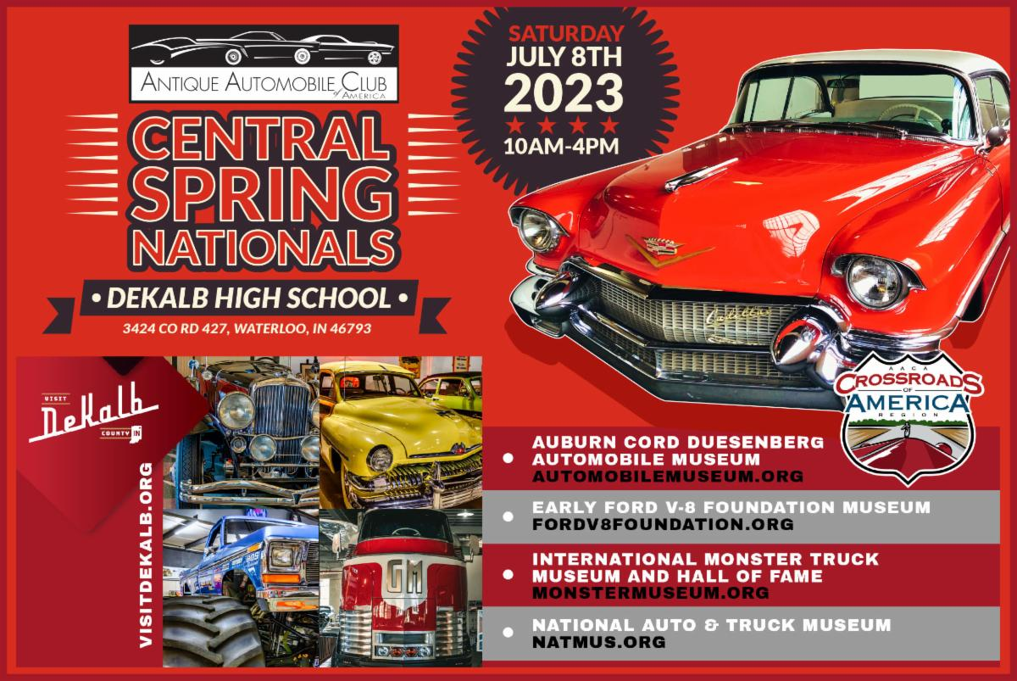

**Oct 14** – GA/AL Region AACA 41st Annual Car Show 8:00 to 2:00@ Forestry 21, 1739 New Franklin Rd. Hwy 27, LaGrange GA.30240

**Oct. 22-27**: **77th Revival AAA Glidden Tour** and the hub is in Thomasville, Georgia. Yes, you read this right. This famous tour is hosted in even years by AACA and in odd years by VMCCA. This is advance notice to our members who have always wanted to drive their pre-War car or truck on the Glidden. Distance from Carrollton is only 232 miles. You will never find one closer. Flyers should be available soon. I know we have current members with very drivable cars which qualify. Drive there or trailer.

**October 24-29:** Classic Thunderbird Club International Southeast Regional Convention, The Villages, Florida. For information, go to

[www.ctci.org](http://www.ctci.org) and click on 2023 Convention tab.

After the Glidden, cruise down into Florida for the final two days of this special car show event, featuring T-Birds from all the decades.

**November 3-5**: Hilton Head Island Concours d’Elegance. The website is https://www.hhiconcours.com/

**Our Club Website:** www.WestGeorgiaAACA.org

**Just for Fun:**

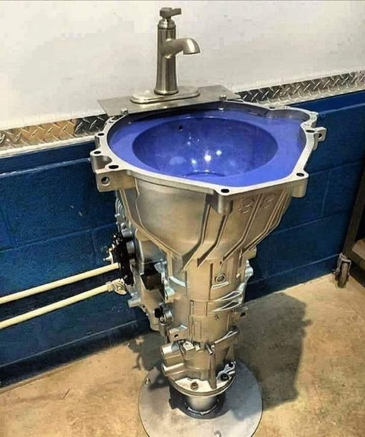

Submitted by Bob Smith

**Photos**

If any members would like to have a picture of their vehicles featured at the top of page one of our newsletters, just email the photo to me and I would be happy to use it. An article in Word, short or long, is also welcome but not necessary. Just send it as a JPEG file in an email attachment to fifteezfan@hotmail.com

