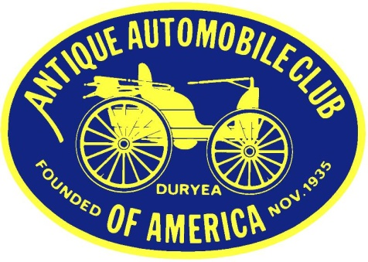**West Georgia Region AACA**

**Membership Application** **Club Contact:**

Debbie Novak

fifteezfan@hotmail.com

D**ate: _______________________**

**Name: ____________________________________________________________________________________**

**Address: __________________________________________________________________________________**

**Home Phone: _________________________________ Cell Phone: __________________________________**

**Email Address: _____________________________________________________________________________**

**Spouse’s Name: _____________________________________________________________________________**

**Cell Phone (optional): _________________________________________________________________________**

**Email Address (optional): _____________________________________________________________________**

**Are you a member, in good standing, of the National AACA?**

**Yes ____ AACA National Membership Number ____________________**

**No ____ You must be a member of the National AACA to become a member of a local Region or Chapter. (If you are NOT currently a member of AACA, you may submit your completed National AACA Application for Membership, along with a separate check for National dues, with this application. You may also join the National AACA by going to the link on our Region’s website,** [**www.westgeorgiaAACA.org**](http://www.westgeorgiaAACA.org)**, or directly to** [**www.aaca.org**](http://www.aaca.org) **and pay dues online.)**

**Year and Make of Antique/Collectible Vehicle(s):**

**(It is not necessary to own an antique or collectible vehicle to be a member.)**

**____________________________________ _______________________________________________**

**____________________________________ _______________________________________________**

**____________________________________ _______________________________________________**

**Special Interests: _________________________________________________________________________**

**________________________________________________________________________________________**

**Applicant’s Signature: _____________________________________________________________________**

***Annual Family Dues ($15) due by January 1st each year (Dues must accompany application)***

***Make check payable to: West Georgia Region/AACA***

**Date Accepted for Membership: _______________________________________**