**The Greasy Rag**

**January, 2023**

**The monthly newsletter of the West Georgia Region of AACA**

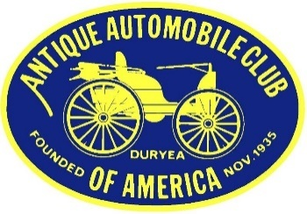

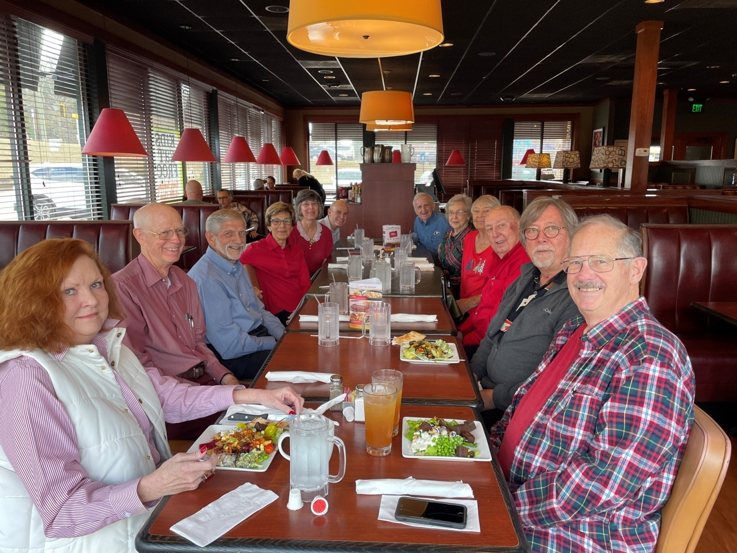

**Twelve current members of our car club showed up this year for the annual Christmas luncheon and enjoyed good company and good food (more photos and full story below)**

**President’s/Editor’s Message Glenn Novak**



I hope everybody had a great Christmas and enjoyed this very special day. I know you enjoyed visiting with family and friends and eating lots of delicious food. Now we have a whole new year ahead of us, and the 2022 Peach Bowl coming up tomorrow. I hope all of our members stay healthy and enjoy the days ahead. Spring may be just around the corner. Let’s try to work on those collector car winter projects.

On a more somber note, we are very saddened to learn of the passing of our good friend and fellow collector car hobbyist, **Greg Marshall**. Greg died on Tuesday, December 27th, following heart surgery at Emory. Those who knew Greg will remember him as friendly, helpful and enthusiastic about the old cars and trucks that he owned and those he admired and judged over the years at AACA Nationals. We will all miss him.

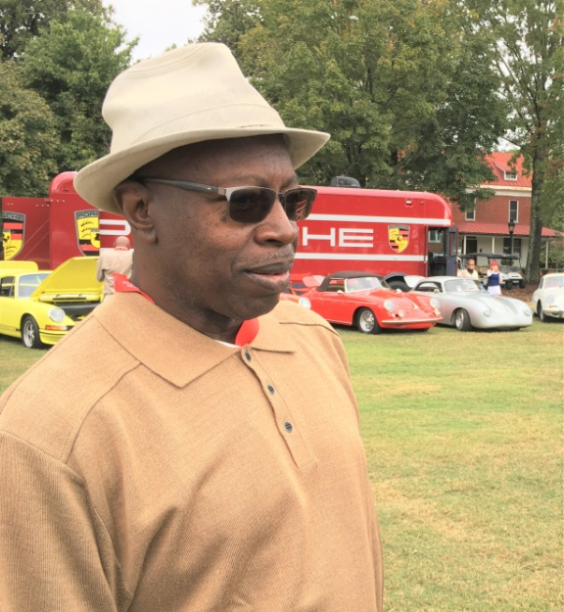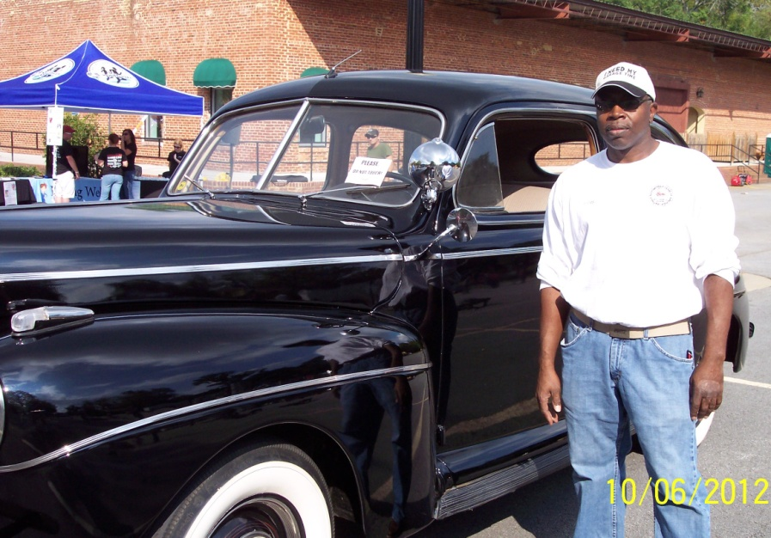

**Membership dues**

If you wish to pay your 2023 local dues, please do ASAP. $15.00 payable to AACA West Georgia Region

Mail to: Jenny Smith: 1141 Hilldale Ct., Villa Rica, GA 30180



**Christmas Lunch/Party re-cap**

**We had 12 club members attend the Christmas lunch at Ruby Tuesday’s on December 8th. Half of this group came back to the Novak’s residence for the afterglow party with assorted desserts, coffee and Coca-Cola. The ‘50’s and ‘60’s electro-mechanical games such as pinball and shuffle bowling got a workout with some folks reliving their youth and actually doing quite well. Too bad we had no awards as incentives.**

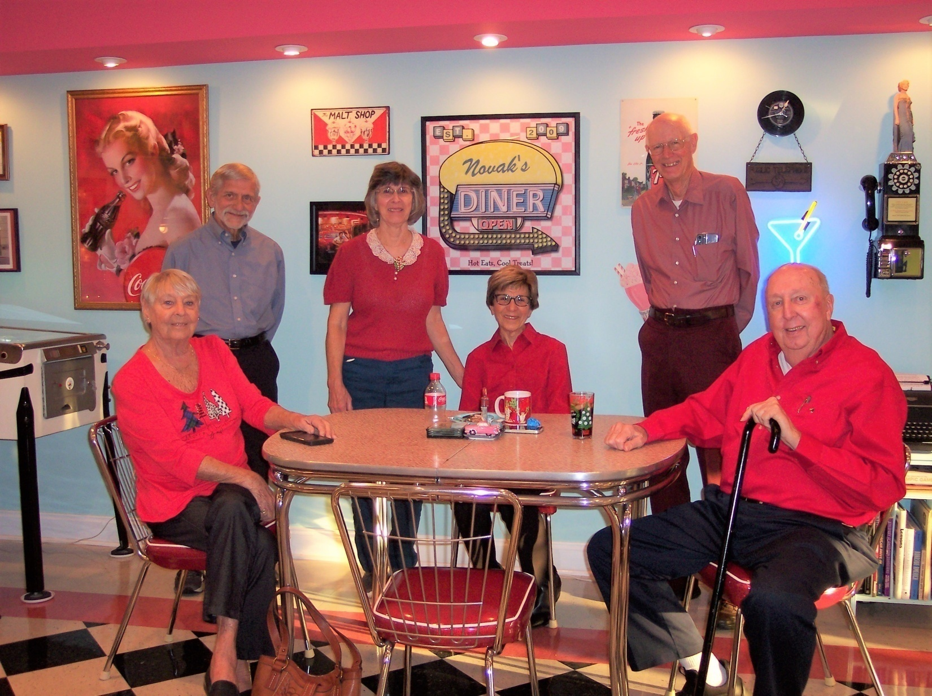

**WGRAACA club members at the 2022 Christmas Party**

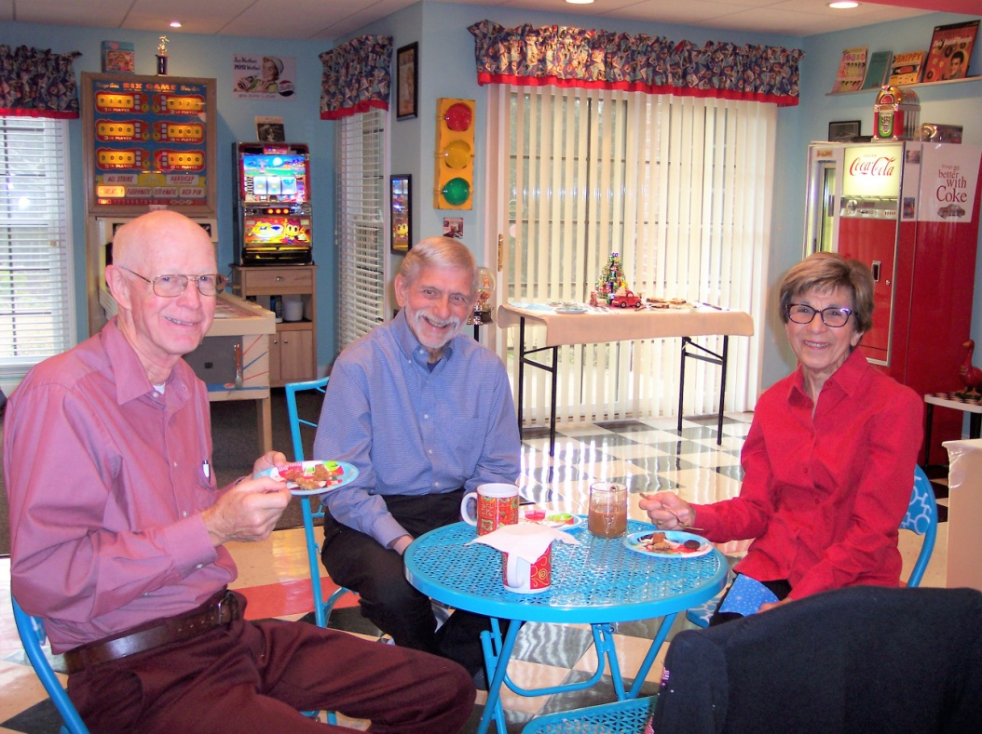

Bob, Gary and Carol enjoying (you guessed it) more food

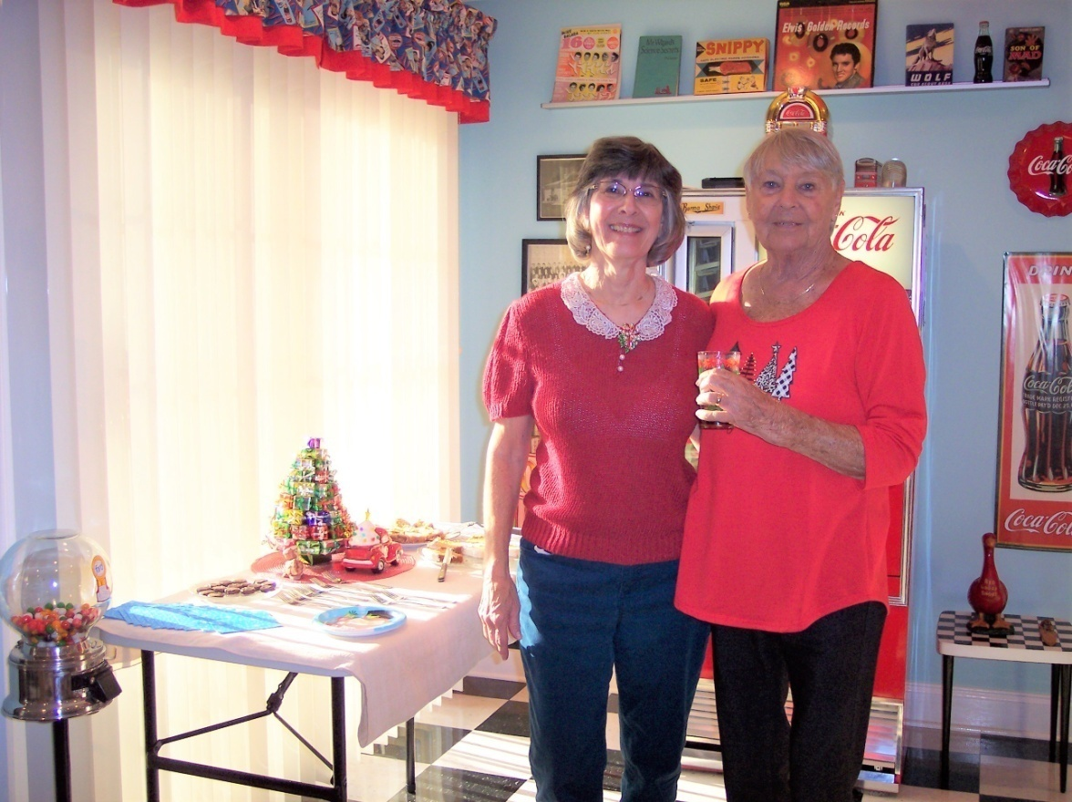

Debbie and Sandy guarding the food table. Red was the color of the day.

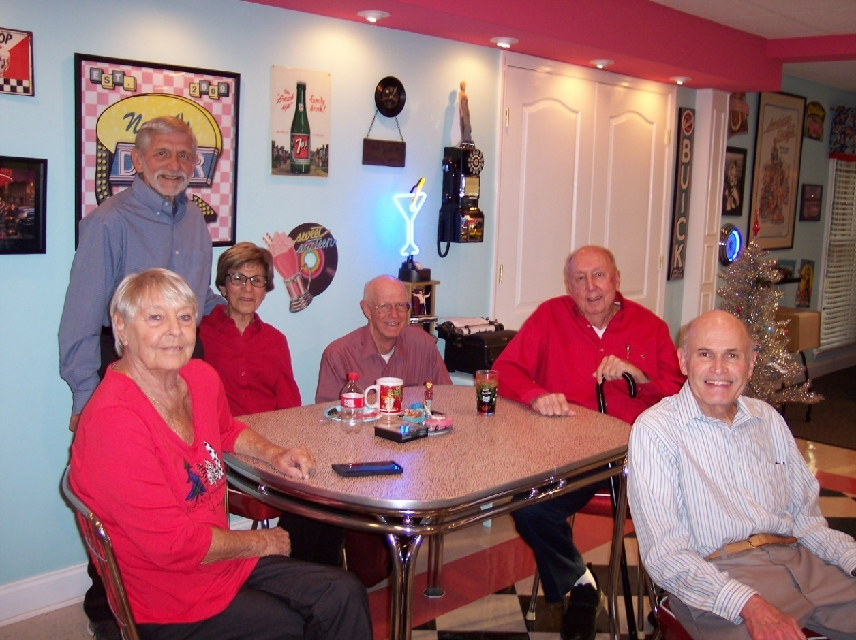

Our small group sitting at a genuine Formica-topped table from the Fifties

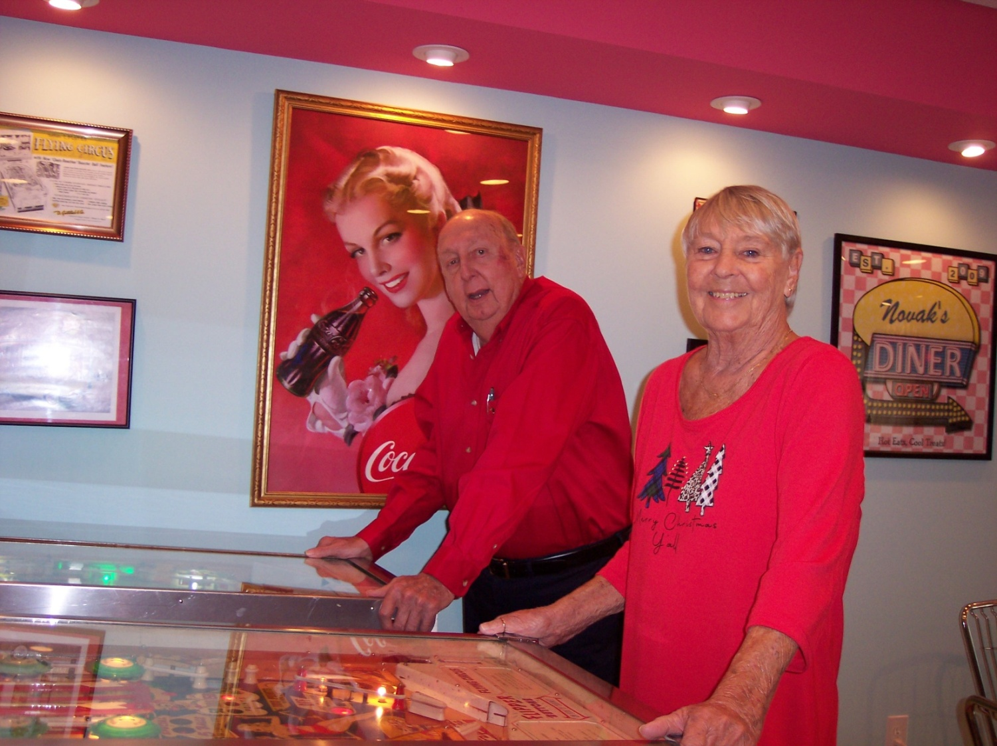

Larry and Sandy exercising their hands and the Gottlieb pinball machine flippers

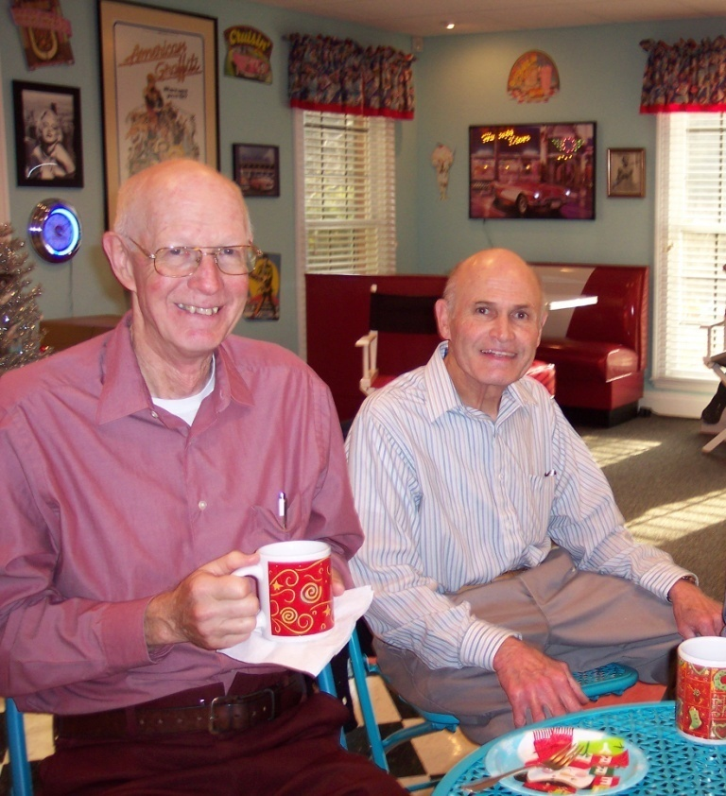

Bob Smith and President Glenn enjoy a cup of coffee

**Club Vice-President Position remains unfilled**

We still have our VP office open. If anyone is interested in serving in this position, please let Glenn know. This person is responsible for calling and conducting club meetings in the absence of the president. Also, the VP plans all of the club activities for 2023. We no longer do the annual car show. The other three officers from 2022 have agreed to continue on for another year. They are as follows:

President: Glenn Novak Secretary: Debbie Novak

Treasurer: Jenny Smith



**Preview of events for 2023**

Our club members had a very good time at the Corvair National Meet in Peachtree City, GA a while back. This event had nothing at all to do with AACA. We just thought it might be fun and interesting, and it was. After all, you might see a Corvair or two at an AACA National Meet someday. For that reason, I am listing some events here that may or may not have something to do with AACA but which members might find interesting. Take a look below and mark your calendars.

Jan 26-28: AACA Winter Nationals, Miami/Ft. Lauderdale, FL 700 mi.

**https://southfloridaregion.aaca.com/winter-national-show/**

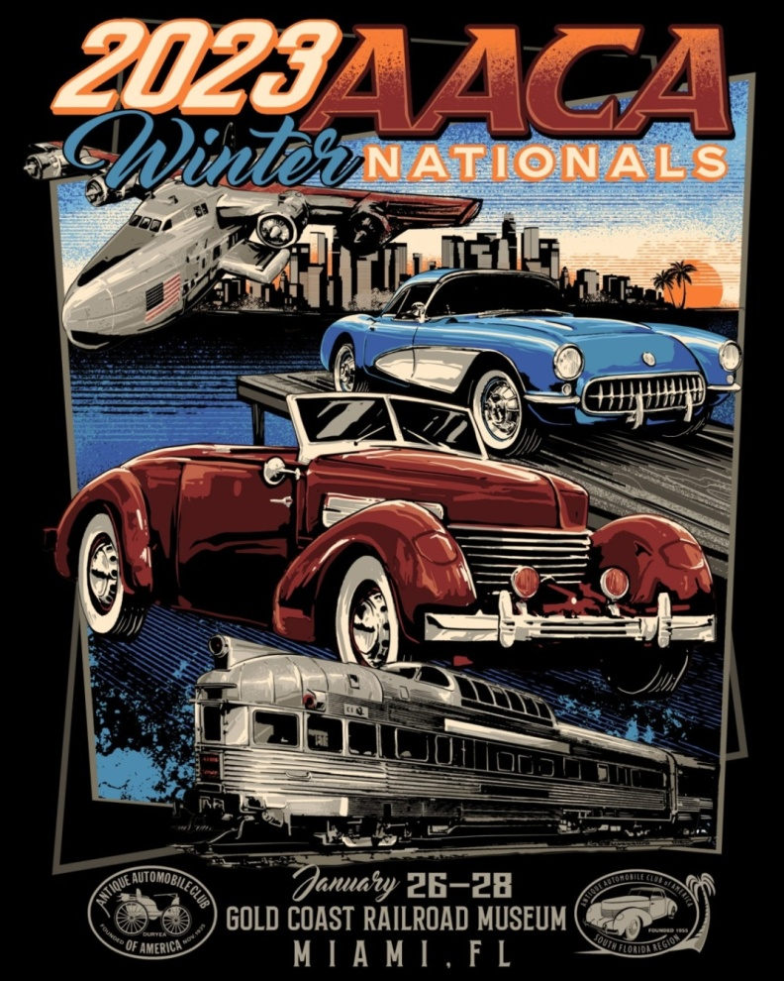

**February, 2023:** Club trip to the Savoy Museum in Cartersville to view the current displays, plus lunch, date/time TBA

**Charlotte AACA** is **April 13-15** and is actually at the Motor Speedway in Concord, NC. From Carrollton, the distance is 313 miles. The flyers and registration materials should be available around January.

**May 6:** Motor Fest on the Showgrounds, Savoy Museum, Cartersville, 8 am to Noon, savoymuseum.org/events-calendar/list/page/2/

**May 5-7: The 2023** **Greenbrier Concours d'Elegance**, ​101 Main Street West, ​White Sulphur Springs, WV 24986, website is https://www.greenbrierconcours.com/ Distance from Carrollton is 507 miles. A very high-end event. More details to follow.

**POCI National Meet** is **June 26 - July 1, 2023** in Murfreesboro, TN. Drive north about 224 miles and see some of the best Pontiacs and Oaklands in the nation. POCI stands for Pontiac Oakland Club International. It is a yearly judged show and you won’t find one any closer any time soon. You do not need to be a member to attend as a spectator. The host hotel is Embassy Suites, 1200 Conference Center Blvd, Murfreesboro, TN 37129 and the event website is https://secure.poci.org/POCI_Featured_News.cfm?Tp=N&PID=45

**77th Revival AAA Glidden Tour** is October 22 - 27, 2023 and the hub is in Thomasville, Georgia. Yes, you read this right. This famous tour is hosted in even years by AACA and in odd years by VMCCA. This is advance notice to our members who have always wanted to drive their pre-War car or truck on the Glidden. Distance from Carrollton is only 232 miles. You will never find one closer. Flyers should be available in the spring. I know we have current members with very drivable cars which qualify. Drive there or trailer.

**For Sale:**

1927 Model T Ford Roadster w/ Rumble Seat. Excellent paint, top and upholstery. Stored in enclosed shop. Actively driven and shown just prior to pandemic. Deceased father’s car, Buddy Graves. Engine Starts and Runs but she doesn’t know how to drive it. Price: $13,000. Contact Melody Graves: 334-524-4648.

**Our Club Website:** www.WestGeorgiaAACA.org



**HAPPY BIRTHDAY**

Gwyneth Shotwell

January 8

