**The Greasy Rag**

**February, 2023**

**The monthly newsletter of the West Georgia Region of AACA**

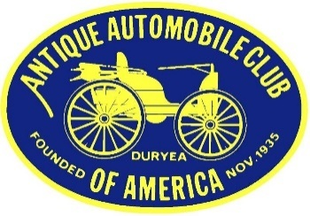

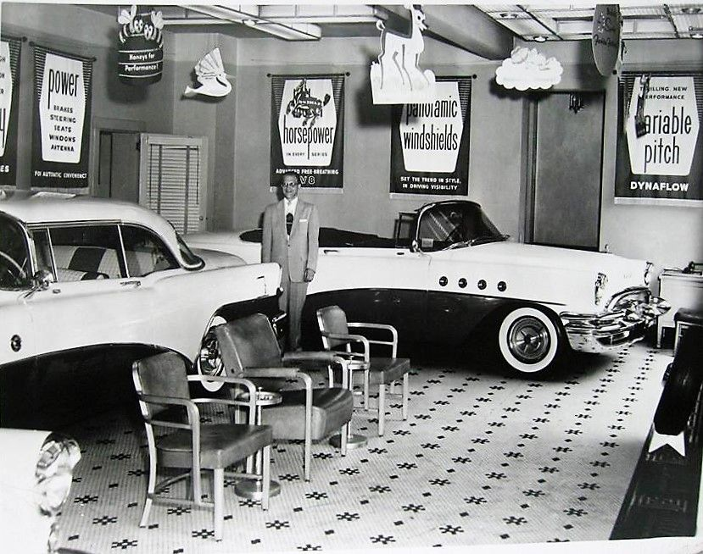

**Come on over and he’ll write up your order**

**President’s/Editor’s Message Glenn Novak**

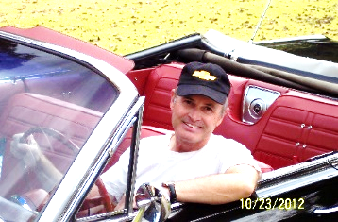

I hope everybody had a good January and that we can all begin to look forward to warmer weather and longer days. February is a slow month so this newsletter is a little lighter on photos. The end of January saw the national meet down in Miami so we can look forward to the summary in a future issue of our magazine. This month is the annual business meeting of our national club where many awards will be given out. And our own local club will have a tour up to the Savoy Automobile Museum in Cartersville on February 25th. Read about the details on this event further down in this newsletter.

**Club Vice-President Position remains unfilled**

We still have our VP office open. If anyone is interested in serving in this position, please let Glenn know. This person is responsible for calling and conducting club meetings in the absence of the president. Also, the VP plans all of the club activities for 2023. We no longer do the annual car show. The other three officers from 2022 have agreed to continue on for another year. They are as follows:

President: Glenn Novak Secretary: Debbie Novak

Treasurer: Jenny Smith

**Our club tour to the Savoy is February 25th**

The Savoy Museum in Cartersville has a very different assortment of cars on display now. This is **NOT a repeat** of what we did last time, other than lunch at their café. What we shall see this time are Fabulous Fins (representative finned monster from GM, Ford and Chrysler); Microcar Marvels (a subset of the huge Lane collection in Nashville), Built for a Crisis (American gas misers of the 70’s), Locally Owned, and Savoy Permanent Collection. Those who wish to caravan up there will meet at the Amp in Villa Rica (home to the Golden City Cruisers monthly cruise-ins and located next door to The Olive Tree restaurant at 150 Stone St, Villa Rica, GA) at 9:30 am and we will take route 61 through Dallas. Or just drive up there on your own schedule and preferred route. GCC and the LaGrange club are also invited. We will have lunch at the Savoy café as before, and straggle home. Be sure to bring your season pass if you have one. This is a rain or shine event.

**Notes on Greg Marshall’s service**

There were a number of car club members in attendance at Greg’s service in Douglasville on Saturday, January 7th. Weather was very good and many collector vehicles occupied the church parking lot**. See Appendix A** to read a copy of the program distributed at the church.

WGRAACA members attending were Gary and Carol Moyses and Glenn and Debbie Novak. Former members were Frank Hummel, Rick and Liz Horne, Jim and Gerrie Nichols and Ellen, and Victor and Raylene Carroll.



Some of our members attended the Corvair National Meet in Peachtree City, GA and the Porsche show at Shot Spot last year. These events had nothing at all to do with AACA. But, we had fun.

**February 25:** Club trip to the Savoy Museum in Cartersville to view the current displays, plus lunch, details in this newsletter above.

**April 1**: Sargent Baptist Church annual car show. Newnan from 9-2.

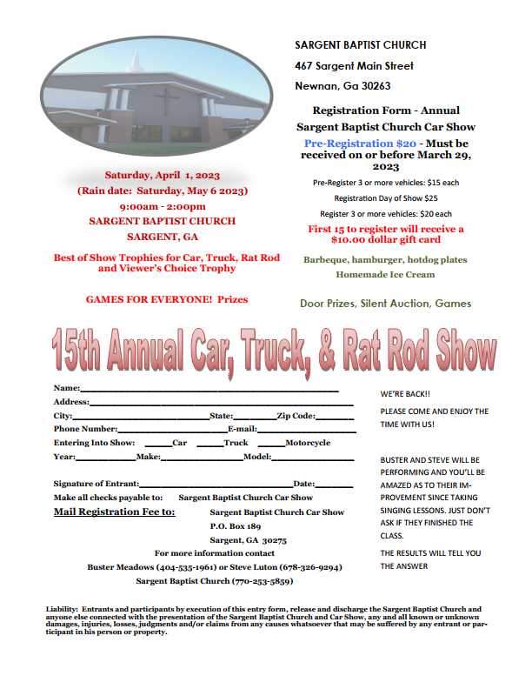

**Charlotte AACA** is **April 13-15** and is actually at the Motor Speedway in Concord, NC. From Carrollton, the distance is 313 miles. The flyers and registration materials should be available around January.

**April 29:** CCAS (College and Career Academy South) car show in Carrollton. Again this year, it will be at College and Career Academy South Campus, 1075 Newnan Road, Carrollton, 30116. This is near the turnaround on Highway 27 and the dump. **I**t will be from 10:00-2:00, and there will be food and trophies as they had last year. CCAS automotive students are putting on the show. The registration fee is $25. Email is [steve.sumner@carrollcountyschools.com](mailto:steve.sumner@carrollcountyschools.com) for more info.

**May 6:** Motor Fest on the Show grounds, Savoy Museum, Cartersville, 8 am to Noon, savoymuseum.org/events-calendar/list/page/2/

**May 5-7: The 2023** **Greenbrier Concours d'Elegance**, ​101 Main Street West, ​White Sulphur Springs, WV 24986, website is https://www.greenbrierconcours.com/ Distance from Carrollton is 507 miles. A very high-end event. More details to follow.

**May 6**: Annual Buick-Olds-Pontiac-Cadillac car show at Piedmont Baptist Church in Marietta, 8 am-3 pm, details at <http://dixie.buickclub.org/wp-content/uploads/2022/11/0522-2023-BOPC.pdf>

**POCI National Meet** is **June 26 - July 1, 2023** in Murfreesboro, TN. Drive north about 224 miles and see some of the best Pontiacs and Oaklands in the nation. POCI stands for Pontiac Oakland Club International. It is a yearly judged show and you won’t find one any closer any time soon. You do not need to be a member to attend as a spectator. The host hotel is Embassy Suites, 1200 Conference Center Blvd, Murfreesboro, TN 37129 and the event website is <https://secure.poci.org/POCI_Featured_News.cfm?Tp=N&PID=45>

**July 6-8:** Just announced in December 2022 Speedster! Central Spring Nationals in Auburn, IN. No details yet. Check magazine and website.

**77th Revival AAA Glidden Tour** is October 22 - 27, 2023 and the hub is in Thomasville, Georgia. Yes, you read this right. This famous tour is hosted in even years by AACA and in odd years by VMCCA. This is advance notice to our members who have always wanted to drive their pre-War car or truck on the Glidden. Distance from Carrollton is only 232 miles. You will never find one closer. Flyers should be available in the spring. I know we have current members with very drivable cars which qualify. Drive there or trailer.

**October 24-29:** Classic Thunderbird Club International Southeast Regional Convention, The Villages, Florida. For information, go to

https://www.ctci.org/ctci-southeast-regional-convention-october-24-29-2023/ After the Glidden, cruise down into Florida for the final two days of this special car show event, featuring T-Birds from all the decades.

**Speaking of car shows**

I received a letter in my email from AACA citing complaints from many members that we have too few national meets in the South. Maybe we should host a national meet, with 400 cars, trained judges, corporate sponsors, side trips, show field logistics, awards banquet, and goody bags. Any volunteers to be Show Chairperson in 2024? Read the letter below in **Appendix B**.

**Our Club Website:** www.WestGeorgiaAACA.org



**Just for Fun:**

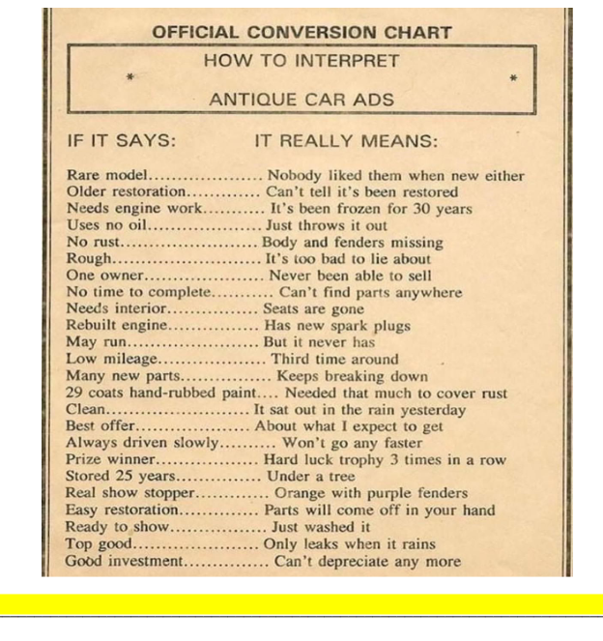



Appendix A

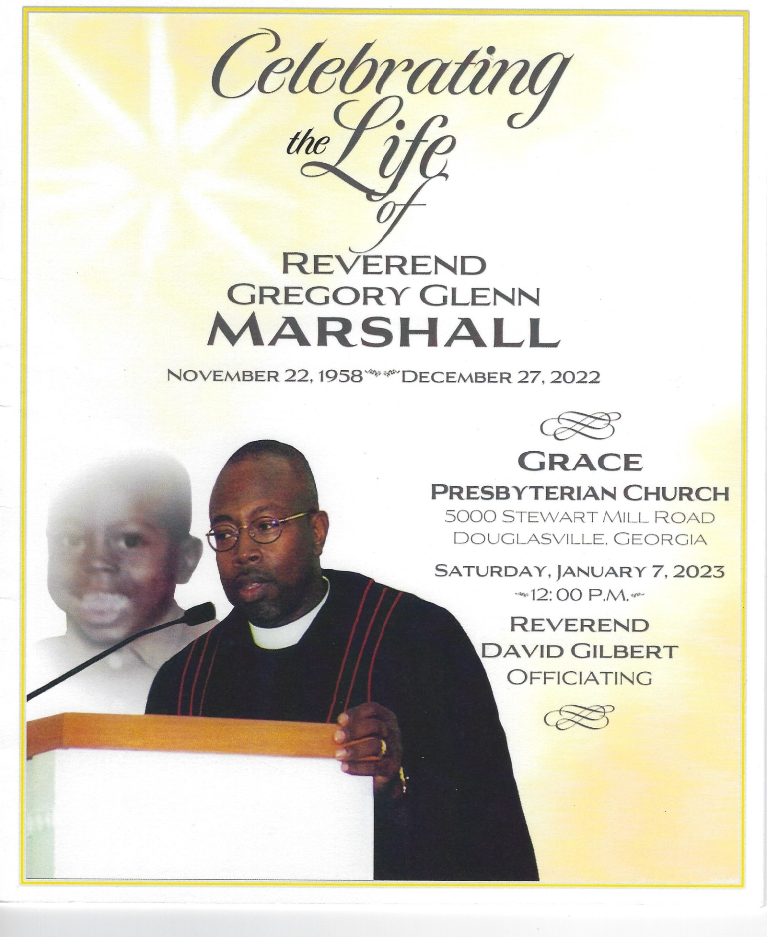



**Appendix B**

Hello;

                I am David Anspach AACA VP of National Activities.  Hardly a day goes by that I don’t hear something about the lack of AACA National Shows and Tours .   I am writing to every Region in the Nation to ask them to consider doing a National Activity.  Trust me when I say I have heard every reason there is about why NOT to do a National Show or Tour, I want to talk about the reasons to do one.

                I hear so often that lack of members is the reason for not doing a show or tour.  First of all, groups as small as 30 have done activities with great success.   Groups even smaller have teamed up with other Regions or groups to pull it off.   Doing a National is one of the best ways to increase your membership.  People want to be part of a group that DOES something.  Almost every group that has done a show or tour has increased their numbers with some doubling their membership.    Is your club declining?  Do an event and watch it turn around!

                Every club is getting older.  As we age, we slow down.  That does not mean we have to stop.  Every person in this hobby has knowledge and experiences to pass on to younger members.   By doing an activity, we attract those younger people to carry on our hobby using the knowledge and experience that us older folks taught them.  I know of a club whose average age was in the mid 70s before an activity.   After they did a show, the average age dropped by almost 15 years.   They didn’t lose their old members, they gained that many younger ones.   Needless to say, those younger members become your “boots on the ground” to do a show or tour.

                All of our groups need the financial wherewithal to do the things we want to do.   Whether it is charitable activities or things to benefit our members it all takes funding.   Done correctly, National activities make a profit for the clubs that do them.   Of course, the big clubs finance their entire year with activities surrounding National events, but smaller shows and tours can do the same.  Many small clubs more than double their annual income from a National activity.  YOU can do it too.   If you don’t know how, just ask!   I’d be happy to personally show you how to make a profit and still have your attendees feel like they have gotten a value for their money!!

                The opportunities for the Southern Division are numerous.   For 2023, although the time is short there is still enough time to plan a Fall National. In 2024, there is a need for a Winter National as well as a Fall National. Numerous Tours including the Divisional Tour, Sentimental, Reliability, and the all important Glidden are needed to be filled. 2025 presents all sorts of opportunities with just about every event that could be staged in the South available

 We constantly hear that there aren’t enough events in the South.  Here is your opportunity to change that and hold an event!!  Won’t your group be the one step up and fill the void!! Without Regions to sponsor and hold the event…there are no events.

If I or any of the staff or board of our organization are able to aid you in considering, organizing, or carrying out an event, PLEASE get back to me ASAP and I will set it up.  I look forward to hearing from you on these important opportunities.  If , by chance , you are already considering doing an event, and if I can help you in the process, please contact me.  If this has reached you in error, feel free to inform me or to forward it to the correct person.  Thank you for your time

David Anspach AACA VP National Activities